Precisely interfacing with the human brain at scale
Opportunity space
v1.0
Jacques Carolan, Programme Director

CONTEXT
This document describes an early opportunity space from which we believe one or more funding programmes can emerge. We’ve sketched out some of our early thinking to spark your interest, and invite you to imagine relevant potential programmes with us, or suggest new directions. We’ll publish updated versions of this document as our thinking evolves.

Sign up at www.aria.org.uk/contact-jacques to receive those updates and learn about any funding opportunities that emerge from this opportunity space.

An ARIA opportunity space should be:
- important if true (i.e. could lead to a significant new capability for society),
- under-explored relative to its potential impact, and
- ripe for new talent, perspectives, or resources to change what’s possible.

SUMMARY
Neurological and neuropsychiatric disorders are the cause of an overwhelming societal and economic burden. We need a new suite of tools that enable us to interface precisely, at scale, with the human brain.

BELIEFS
- Targeted interaction with the human brain can improve the human condition across an incredibly wide range of disease states and cognitive domains → we need to dramatically and safely increase the throughput (# procedures/day/£) at which these technologies can be deployed to understand their full potential and deliver them at scale.
- Current paradigms for interfacing with the human brain trade off precision for invasiveness of the procedure → there’s no fundamental reason we can’t build technologies that are both highly targeted and minimally invasive.
- To fully understand and treat disorders of the brain, we'll need neural technologies that simultaneously offer chemical, temporal, and spatial specificity → this is achievable only by connecting the frontiers of engineered hardware with the frontiers of engineered biology.

OBSERVATIONS
Sign posts as to why we see this area as important, under-explored, and ripe.
- In the UK alone, the direct and indirect cost of brain disorders is >£100Bn/year and the cost of developing new pharmaceutical interventions is increasing exponentially.

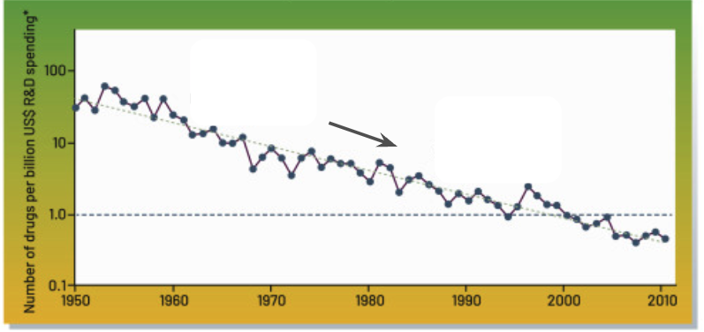

- Figure 1: The graph shows the number of drugs per billion US$ R&D spending on the y-axis decreasing exponentially D as a function of year on the x-axis.

- Emerging evidence suggests that deep brain stimulators can be effective for a much wider range of treatments than previously envisioned, including drug resistant depression, Tourette's syndrome, mood and anxiety disorders, substance addiction and Alzheimer's disease. Note from Jacques - This points towards a vast pool of people whose lives could be transformed by targeted modulation of the central nervous system.

- There are currently ~400 DBS implants performed in the UK per year. In contrast ~50,000 cardiac pacemakers are implanted per year.
Note from Jacques – How can we make precise neuromodulatory technology at least as safe and routine as pacemaker surgery?

- Our current methods for interfacing with the human brain trade off targeting precision with invasiveness.

- Ultrasound can penetrate through the skull into deep brain regions, and can also directly modulate neural activity via mechanosensitive ion channels.
Note from Jacques – Can we engineer ultrasound to deliver transcranial acoustic signals with cellular level precision?

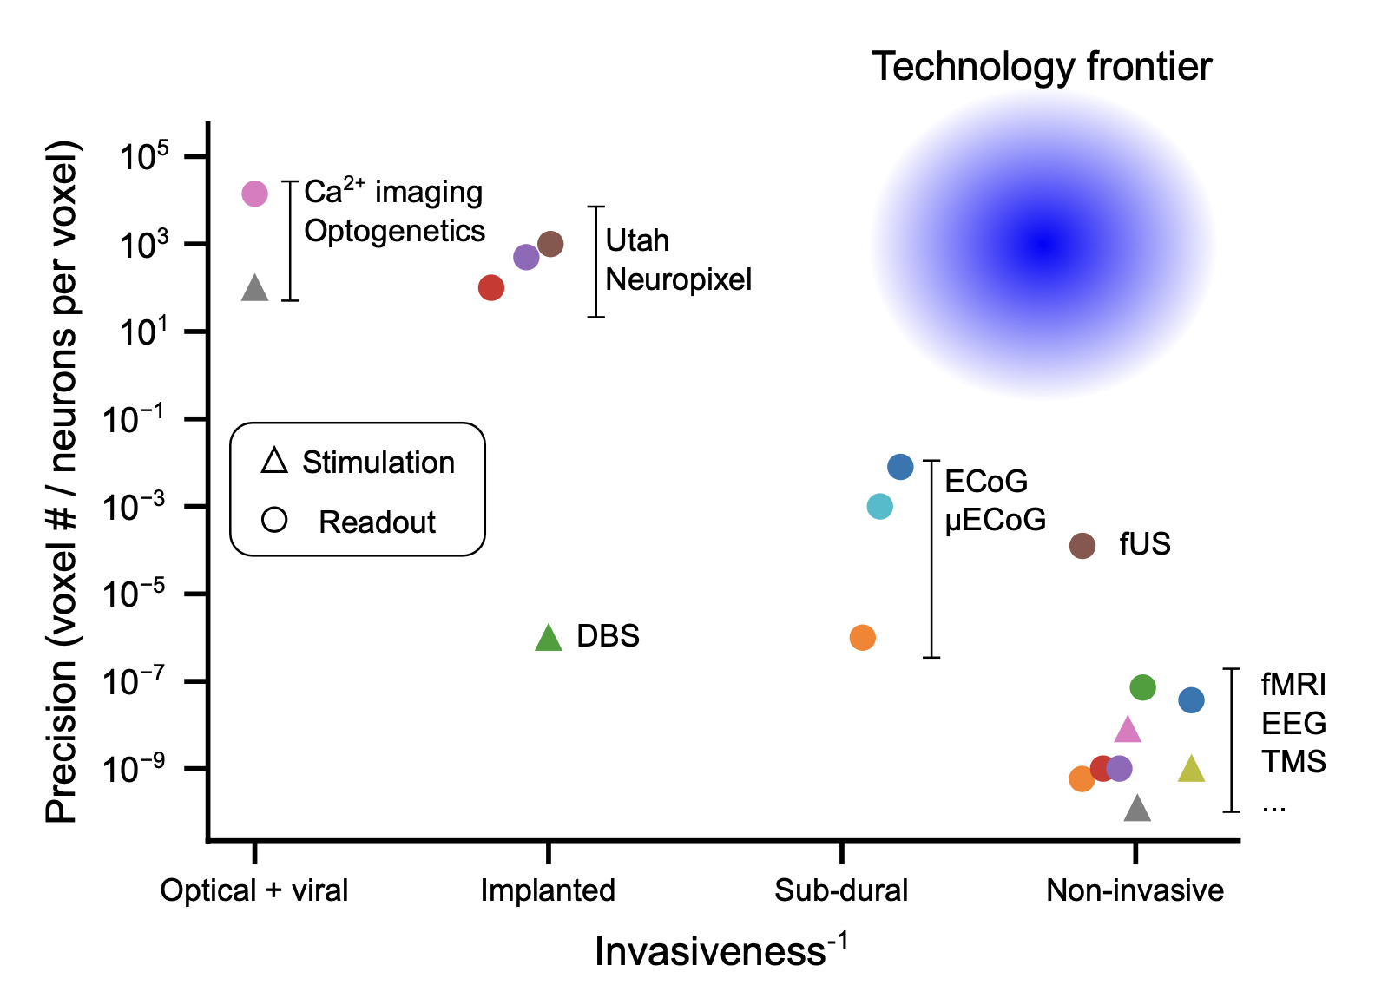
- Figure 2: The graph plots the precision of various neurotechnologies (voxel # / neurons per voxel) on the y-axis alongside their invasiveness on the x-axis, showing that as the technology becomes more precise it generally becomes more invasive. A circle is highlighted in the non-invasive-precise area title ‘technology frontier’. .
Note from Jacques — What technologies could go in the frontier?

- Technology advances in optical microscopy, genetic engineering, large-scale electrophysiology and computational signal processing have led to an exponential increase in the number of individual neurons that can be simultaneously recorded from in rodent models.

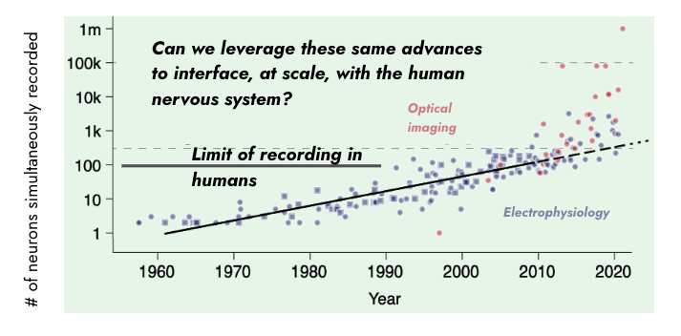
- Figure 3: The graph shows the number of neurons simultaneously recorded from in rodent models, on the y-axis vs the year on the x-axis. The data points are separated between optical recordings and electrophysiology recordings The graph shows an exponential increase in the number of neurons recorded. The current limit of recording from humans is marked on the y-axis at 100 neurons
Note from Jacques — Can we leverage these same advances to interface at scale with the human nervous system?

- Neuroendovascular stents, which are used in a clinical setting to minimally invasively treat brain aneurysms, have been augmented with neural sensing capabilities for brain-computer interfaces.
Note from Jacques — What other clinical packaging platforms could be used as high-performance neural sensing and/or stimulation devices? Would such systems reduce the regulatory burden towards getting devices approved for in-human use?

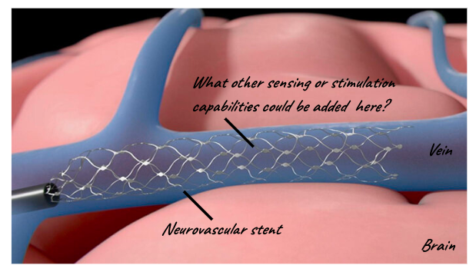

- Figure 4: The image is a diagram of a neurovascular stent with electrode recording technology.
Note from Jacques — What other sensing or stimulation capabilities could be added to neurovascular stents?

- Exponential advances in single-cell sequencing have given us unprecedented access to the molecular identity and cell-type information of neurons across the human brain.
Note from Jacques — How can we use this information to readout or modulate neural activity with cell-type specificity?

- Neurological conditions are highly complex, often involving dysfunctions of neural circuits defined by specific spatial locations and distinct cell-types. For example, we have only recently begun to understand the complex interaction between tumour cells and healthy cells in glioma (the most common type of brain cancer).
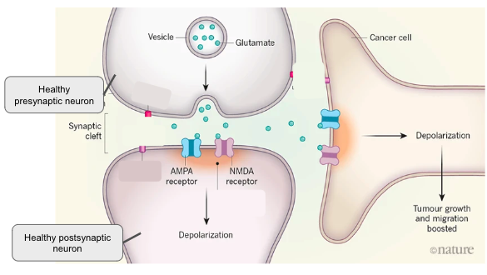

- Figure 5: The diagram depicts the mechanism of glioma proliferation at the level of individual neurons. It shows a zoom in of a synaptic connection between two healthy neurons, with a cancer cell synapsing onto the healthy neurons. The depolarisation of the healthy neurons, depolarises the tumour cells and drives tumour growth. This diagram is adapted from reference 6.
Note from Jacques — Could a neurotechnology identify and block/weaken this synapse weight?

- Implanted cortical interfaces have enabled individuals with paralysis to use brain signals to generate words at a rate approaching that of regular speech.
Note from Jacques — In the future, could such systems enable entirely new modalities of communication in healthy individuals?

SOURCES
A compiled, but not exhaustive list of works helping to shape our view and frame the opportunity space (for those who want to dig deeper).

- The size, burden and cost of disorders of the brain in the UK
- Developing Collaborative Platforms to Advance Neurotechnology and Its Translation (Fig 1)
- Large-scale neural recordings call for new insights to link brain and behavior (Fig 3)
- Physical principles for scalable neural recording
- Cause Area: Differential Neurotechnology Development
- Dangerous liaisons as tumour cells form synapses with neurons (Fig 5)
- Development of optically controlled “living electrodes” with long-projecting axon tracts for a synaptic brain-machine interface
- Neuroendovascular brain computer interfaces from Synchron (Fig 4)
- Brain implants that enable speech pass performance milestones
- Brain-machine interfaces: From basic science to neuroprostheses and neurorehabilitation

ENGAGE
We invite you to shape our efforts by providing feedback and surfacing breakthrough ideas related to this opportunity space. Our next step will be to formulate a programme that directs funding across research disciplines or institutions toward a focused objective. We also plan to open up seed funding for researchers whose bold aspirations are unlikely to be funded elsewhere.

Sign up for updates and share your feedback at www.aria.org.uk/contact-jacques — we will read anything you send.

