Managing our climate and weather through responsible engineering
Opportunity space
v1.0
Mark Symes, Programme Director

CONTEXT
This document describes an early opportunity space from which we believe one or more funding programmes can emerge. We’ve sketched out some of our early thinking to spark your interest, and invite you to imagine relevant potential programmes with us, or suggest new directions. We’ll publish updated versions of this document as our thinking evolves.

Sign up at www.aria.org.uk/contact-mark to receive those updates and learn about any funding opportunities that emerge from this opportunity space.

An ARIA opportunity space should be:
- important if true (i.e. could lead to a significant new capability for society),
- under-explored relative to its potential impact, and
- ripe for new talent, perspectives, or resources to change what’s possible.

SUMMARY
If an abrupt alteration in a climate system were to unfold, we would have no tools to mitigate the effects. Through research, we could understand the science behind how we might intervene to responsibly manage the climate and weather. For more on our approach, read our Q&A here (https://ariaresearch.substack.com/p/833c81a3-bac9-4a51-ab17-0b90ee95a87e)

BELIEFS

- Climate tipping points (abrupt changes to the Earth’s climate) like the melting of large ice sheets or sudden changes in ocean currents have happened in the past. The next one could be imminent → but we have no options for how we might intervene on the timescales required to avert disaster.
- Through carefully-considered engineering solutions → it may eventually be possible to actively and responsibly control the climate and weather at regional and global scale.
- Modern computing allows us to model the climate with unprecedented precision, providing a basis for increasingly confident prediction and validation of research-scale climate control experiments. Coupled with the imperative to address the consequences of anthropogenic climate change → there is a unique combination of push-pull factors pushing us to explore the development of a new climate control R&D community.

OBSERVATIONS
Sign posts as to why we see this area as important, under-explored, and ripe.

- April 1815 – Mount Tambora erupted in Indonesia. Huge quantities of dust + aerosols were released into the atmosphere. In the year following: the average global temperature dropped by 0.4–0.7 °C; Europe experienced its coldest summer in the last 250 years. Famine + economic disruption followed.
Note from Mark — How could we respond if something similar happened again?
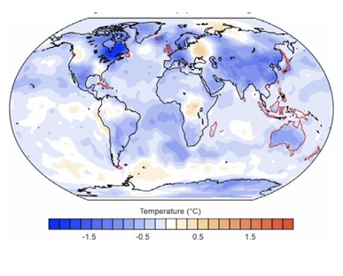
- Figure 1: This image shows average temperature in 1816 relative to 1779-1808.

- Current trends in global temperatures driven by human activity suggest we’re on course to exceed 1.5 °C above pre-industrial levels within 10-20 years, and 3-4 °C by 2100. The buffering capacity of the oceans will lead to a significant time lag between emission and maximal warming effect.

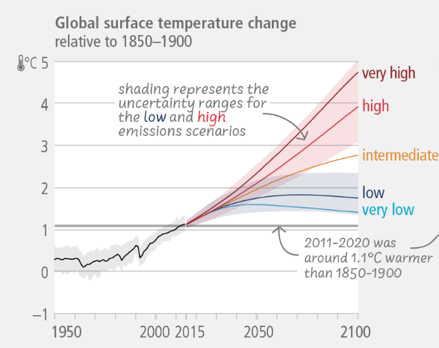

- Figure 2: This graph shows projected global surface temperature changes under various emissions scenarios. Under a very high emissions scenario, the temperature change level would rise by 5°C by 2100 relative to the 1850-1900 baseline.

Event | Likelihood | Effects | Impact | Mark’s risk rating
West Antarctic ice sheet melts | 4 | Global sea levels rise by ~1.5m by 2150 and 5m by 2500 | 5 | Extreme
Atlantic meridional overturning circulation | 3 (by 2070) | NW Europe cools by 10-15 celsius | 4-5 | Very high
Methane release from permafrost | 2 - 4 ? | Dramatically accelerated heating | 4 | High?
Dieback of Amazon rainforest | 3 (by 2070) | Global precipitation patterns disrupted | 3 | Medium
Yellowstone Supervolcano erupts | 1 | Mass extinction via volcanic winter | 5 | Medium

- The table provides Mark’s (incomplete) risk register of potential climate tipping points, assuming 3-4 °C warming above pre-industrial levels by 2100. In many cases, the likelihood and potential effects of such events are only poorly constrained. Likelihood and impact scales: 1 = very low; 5 = very high.
Note from Mark — Could we develop the capability to intervene and prevent, rather than only react?

- Any trials of climate and weather control technologies should rely on close engagement with governments, policy makers and the public. Governance and policy are likely to become major geopolitical issues.
Note from Mark — What standards and protocols should we adopt for safe trails of such technologies? How should the impact on local communities and the natural environment be accounted for and measured?

- What technological options are there that are workable, scalable, ethical and for which the benefits outweigh the drawbacks? What civil engineering and improved land use solutions might there be for controlling the climate at local and global scale?

- The development and testing of hardware for controlling the weather and climate remains massively underserved. Very few trials of any technologies for weather or climate control have taken place.
Note from Mark — Surely there are more options than just stratospheric aerosol injection or cloud brightening?

- The economic cost of extreme weather events is significant (and rising), and the potential economic gains of developing technologies for control of the climate and weather are likely to be considerable.
Note from Mark — In contrast, total global spend on climate engineering research over the last fifty years has been minimal.
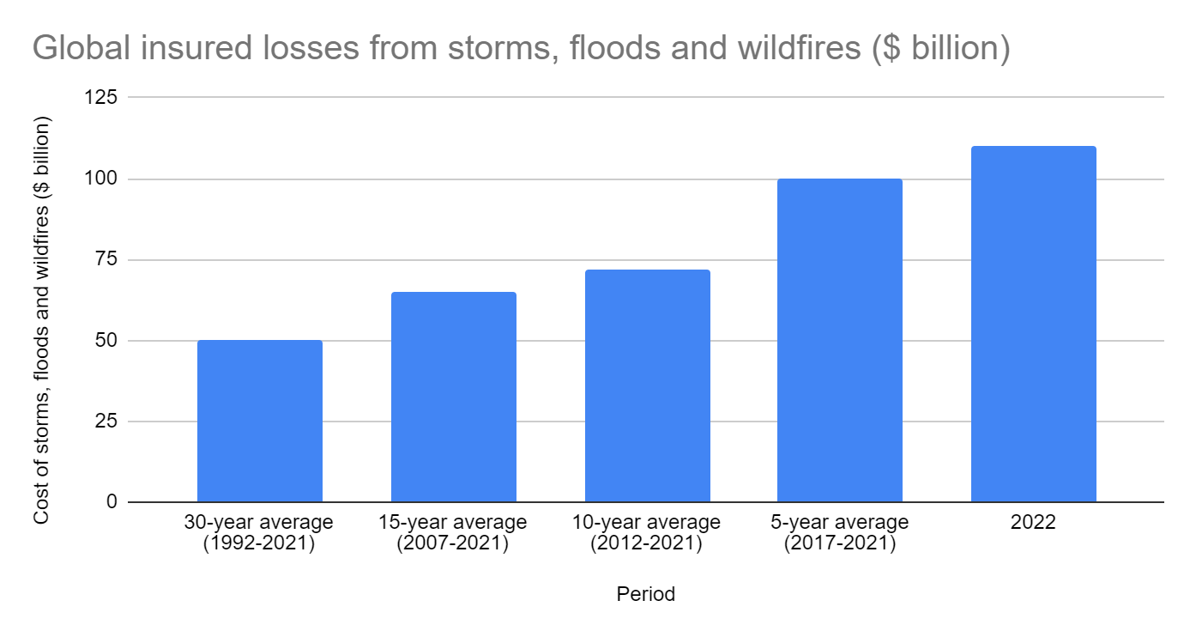

- Figure 3: This graph shows the total cost ($BN) to insurers of storms, floods and wildfires over various rolling average time periods. The graph shows the costs increasing from 1992-2022.
Note from Mark — What role could financial institutions and markets play in climate control? Could ‘climate cooling credits’ incentivise progres?

- The resolution and accuracy of climate and weather prediction models has increased dramatically in recent years.

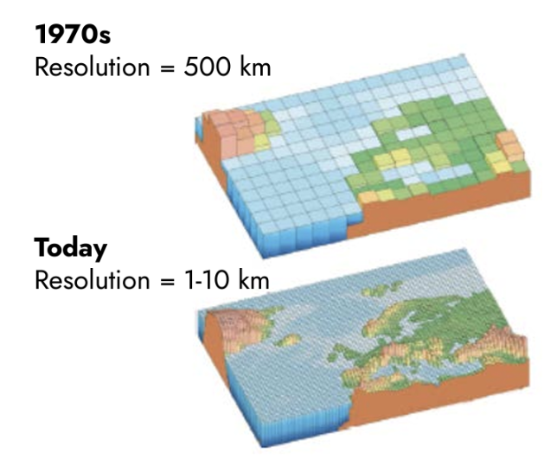
- Figure 4: This image is a cartoon, showing the increased resolution in climate models over the past 50 years.

- Progress in simulation and monitoring capabilities will allow for increasingly robust evaluation of the most effective and responsible options.

- We are already conducting passive climate engineering experiments. In 2020, new rules led to an abrupt drop in global sulfur dioxide emissions from shipping. Sulfur dioxide forms aerosols that reflect sunlight, producing a net cooling effect. By 2050, the effect of removing sulfur dioxide from shipping fuel has been predicted to increase global temperatures by roughly the same amount as two additional years of carbon dioxide emissions at current rates.
Note from Mark — The scale of such “unintentional climate interventions provides perspective for small, carefully-controlled trials of climate and weather management methods.

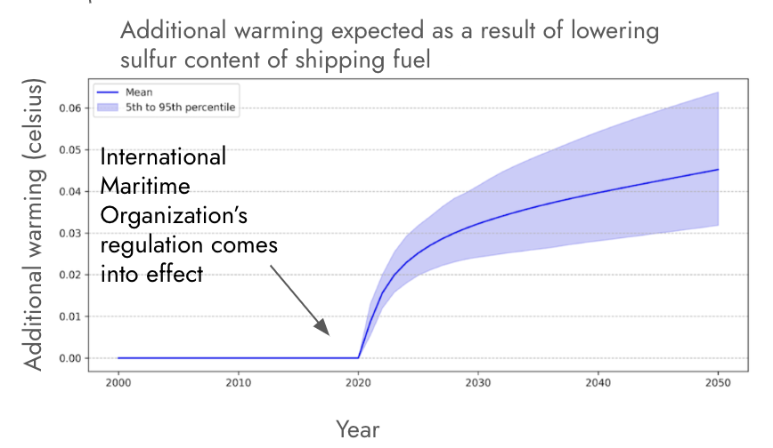
- Figure 5: This graph shows the additional warming in degrees predicted as a result of the International Maritime Organization’s regulations, introduced in 2020, to lower the sulfur content of shipping fuels.

- With a trusted, reliable, and responsible climate and weather control toolkit, interventions could be accurately predicted beforehand at both local and global scales, opening up possibilities for proactive management and mitigation strategies.
Note from Mark — What possibilities would that open up? Mitigating severe weather events like droughts and hurricanes? Stopping the Arctic ice caps from melting? Greening the deserts? Terraforming other worlds?

SOURCES
A compiled, but not exhaustive list of works helping to shape our view and frame the opportunity space (for those who want to dig deeper).
- The Great Tambora eruption in 1815 and its aftermath
- Disentangling the causes of the 1816 European year without a summer
- Tambora and its relevance for future sunlight-blocking catastrophes (Figure 1)
- NOAA National Centers for Environmental Information — global climate report for 2022
- The time lag between a carbon dioxide emission and maximum warming increases with the size of the emission
- World Meteorological Organization — global temperatures set to reach new records in next five years
- Intergovernmental Panel on Climate Change’s sixth assessment report (Figure 2)
- Observationally-constrained Projections of an ice-free Arctic even under a low emission scenario
- Exceeding 1.5°C global warming could trigger multiple climate tipping points
- Tipping elements in the earth’s climate system
- The geoengineering model intercomparison project phase 6 (GeoMIP6) — simulation design and preliminary results
- Geoengineering the climate: science, governance and uncertainty
- Analysis: How low-sulphur shipping rules are affecting global warming (Figure 5)
- Medium ​​- Global insured losses from natural catastrophe events in 2022 (Figure 3)
- Climate change 2007: the physical science basis (Figure 4)

ENGAGE
We invite you to shape our efforts by providing feedback and surfacing breakthrough ideas related to this opportunity space. Our next step will be to formulate a programme that directs funding across research disciplines or institutions toward a focused objective. We also plan to open up seed funding for researchers whose bold aspirations are unlikely to be funded elsewhere.

Sign up for updates and share your feedback at www.aria.org.uk/contact-mark — we will read anything you send.

