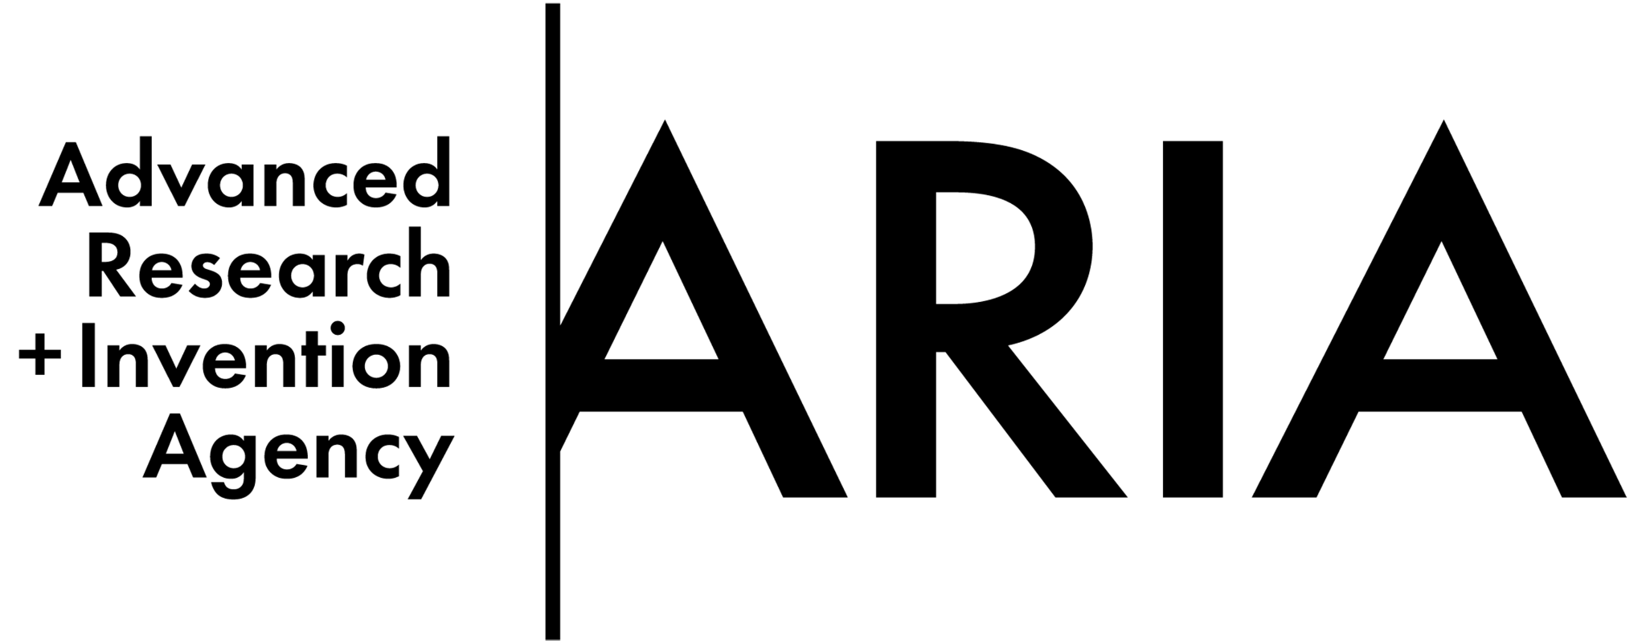

Scoping our planet: a new lens on climate science
Opportunity space
v1.0
Gemma Bale and Sarah Bohndiek, Programme Directors

CONTEXT
This document describes an early opportunity space from which we believe one or more funding programmes can emerge. We’ve sketched out some of our early thinking to spark your interest, and invite you to imagine relevant potential programmes with us, or suggest new directions. We’ll publish updated versions of this document as our thinking evolves.

Sign up here [www.aria.org.uk/contact-sarah-gemma] to receive those updates and learn about any funding opportunities that emerge from this opportunity space.

An ARIA opportunity space should be:
- important if true (i.e. could lead to a significant new capability for society),
- under-explored relative to its potential impact, and
- ripe for new talent, perspectives, or resources to change what’s possible.

SUMMARY
Current Earth system measurements have serious gaps that lead to uncertainties in weather
forecasting and climate predictions. By harnessing the power of optics we can fill these
gaps, equipping society to respond confidently to the climate crisis.

BELIEFS
The core beliefs that underpin/bound this area of opportunity.

- Current climate measurements fail to provide the coverage, resolution or sensitivity necessary to confidently understand and respond to the climate crisis -> we need disruptive technologies to parameterise the entire Earth system.
- Monitoring and modelling are crucial for effective climate management, but both are limited by measurement gaps -> without better measurements we won’t succeed in climate change mitigation, adaptation, or intervention.
- We have entered a new era of optics and photonics, with unprecedented control of light and its interactions with the environment, from molecular to global scales -> new inventions from the optics community are poised to fill the climate measurement gaps.

OBSERVATIONS
Some signposts as to why we see this area as important, underserved, and ripe.

- Billions of Earth observations are made daily, from satellites to weather stations, but there are major gaps in sensitivity, resolution and coverage. [1,2]
Note from Gemma and Sarah – Could new optical tech fill these gaps?

- Accurate time series are needed to observe subtle climate changes over the natural background. Oceanic carbon changes by just 0.007 %/yr due to human activities – a drop in the ocean – difficult to detect but vital for local measurement, reporting and verification (MRV). [3]
Note from Gemma and Sarah – How do we improve sensitivity of in-situ measurements?
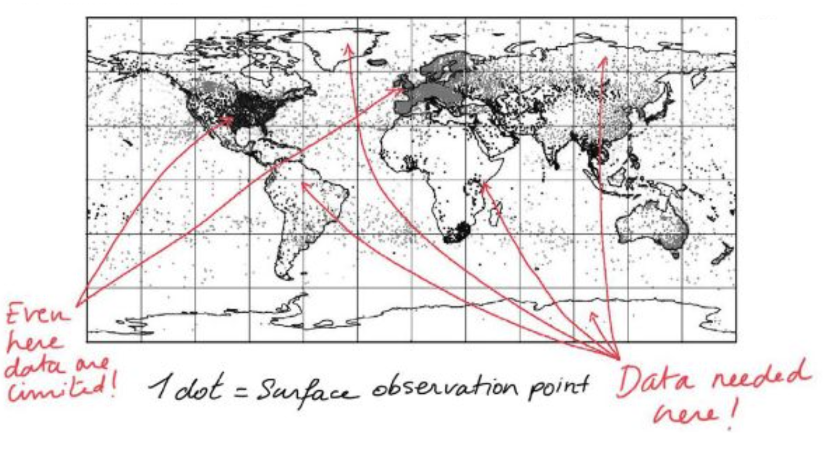
- Figure 1: Black and white map of the Earth showing surface observations with grey dots. The oceans, South America, central Africa, the Arctic and Antarctic are almost completely white with very few dots; red arrows point to these regions with a note from Gemma and Sarah.
Note from Gemma and Sarah – Data needed here!
North America, Europe, South Africa and South East Asia are the most densely covered with grey dots; red arrows point to these regions with a note from Gemma and Sarah.
Note from Gemma and Sarah – Even here, data are limited!

- Both land and air measurements are sparse in the global south; the oceans are globally under-observed. More observations will transform forecast accuracy, supporting communities who need them most. [4,5]

- Instrument resolutions can be multiple orders of magnitude (spatially and temporally) away from the physical processes they are measuring. Huge uncertainties in the contribution of clouds to the Earth’s energy balance arise from a lack of observations at the scales that matter. [6,7]
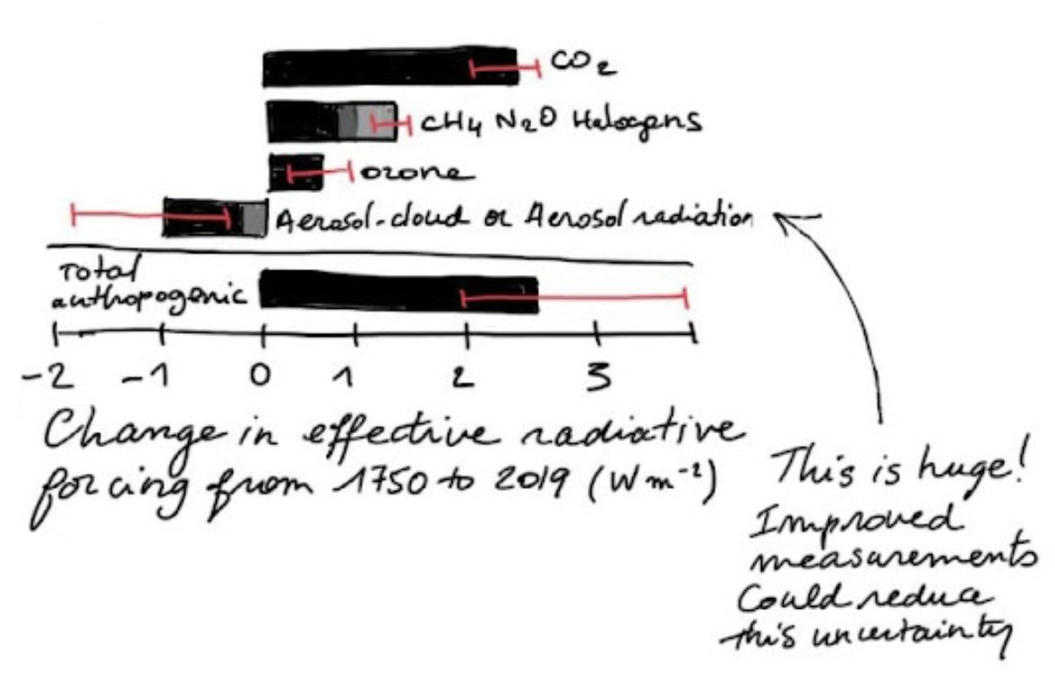
- Figure 2: Bar chart showing the sources of contributions towards anthropogenic warming including CO₂, CH₄, N₂O, halogens, ozone, aerosol-cloud aerosol-radiation, and total anthropogenic. X-axis is labelled “Change in effective radiative forcing from 1750 to 2019 (W m⁻²)”. The error bars on aerosol-cloud aerosol-radiation and total anthropogenic contributions are very large. An arrow points to the aerosol-cloud aerosol-radiation error bar with a note from Gemma and Sarah –
This is huge! Improved measurements could reduce this uncertainty.

- Better measurements underpin more accurate climate predictions, which can create £trillions of economic benefits and allow for enhanced planning to save lives [8, 9, 10, 11].
Note from Gemma and Sarah – You can’t manage what you can’t measure.

- By creating accurate, reliable, portable instruments that can be distributed globally and measure a range of parameters, we can enhance weather forecasts and climate projections, providing early warning signs of extreme weather events and tipping points. [12, 13]
Note from Gemma and Sarah – Where will the next change in climate monitoring come from?
- Figure 4: A sketch of the ocean, land and atmosphere with a vertical scale (from -3km at bottom of the ocean to 30,000km at top of atmosphere). There are three magnifying glasses with scientific questions inside over the clouds, land and ocean. Notes from Gemma and Sarah –
How, when and where do clouds form? Can we use wavefront shaping to see the composition of clouds?
How much methane is permafrost releasing? Will advances in mid-infrared detectors enable us to monitor this in-situ?
How are carbon reservoirs changing in real-time? What breakthrough in spectroscopy is needed to answer this?

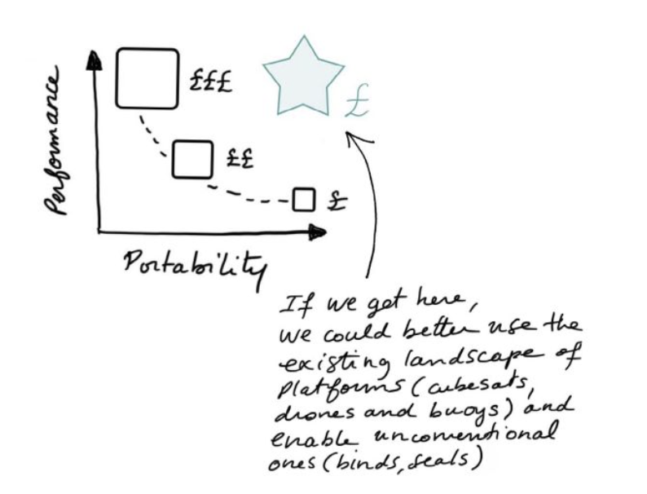
- Figure 3: Sketched plot of performance against portability. Three squares represent the current state of the art: a large one with £££ annotated that sits top left (high performance, low portability), a medium one with ££ annotated that sits bottom left (medium performance, medium portability), and a small one with £ annotated that sits bottom right (low performance, high portability). A blue star sits top right (high performance, high portability) with £ annotated and a note from Gemma and Sarah. Note from Gemma and Sarah –
If we get here, we could better use the existing landscape of platforms (cubesats, drones and buoys) and enable unconventional ones (birds, seals).

- Optics and photonics technologies are low-cost and scalable, so have revolutionised our daily lives [14,15]. Technologies emerging in other application areas could fill the climate measurement gaps.
Note from Gemma and Sarah - Hyperspectral imaging from defence? Adaptive optics from astronomy? AI-enabled super-resolution from imaging? Interferometry from ophthalmology?

SOURCES
A compiled, but not exhaustive list of works helping to shape our view and frame the opportunity space (for those who want to dig deeper).

- Global Climate Observing System 2021 Report
- Vision for the WMO Integrated Global Observing System in 2040
- Global Carbon and other Biogeochemical Cycles and Feedbacks
- Can AI help weather forecasting save lives?
- Gridded precipitation and temperature reference datasets in climate change impact studies
- The impact of aerosols on global climate
- Clearing clouds of uncertainty (Figure 4)
- The Earth’s Energy Budget, Climate Feedbacks and Climate Sensitivity (Adapted in Figure 2)
- Value of information for climate observing systems
- The $10 trillion value of better information about the transient climate response
- Designing the Climate Observing System of the Future
- How a 1.5°C increase triggers climate tipping points
- Global tipping points
- The future of photonics: the best is yet to come
- The health of photonics
- How methane is linked to warming in Siberian tundra (Figure 4)
- Marine pCO₂ measurement technology developments (Figure 4)

ENGAGE
We invite you to shape our efforts by providing feedback and surfacing breakthrough ideas related to this opportunity space. Our next step will be to formulate a programme that directs funding across research disciplines or institutions toward a focused objective. We also plan to open up seed funding for researchers whose bold aspirations are unlikely to be funded elsewhere.

Sign up for updates and share your feedback here [www.aria.org.uk/contact-sarah-gemma] – we will read anything you send.

