Smart machines need smarter bodies
Opportunity Space
v1.0
Jenny C. A. Read, Programme Director

CONTEXT
This document describes an early opportunity space from which we believe one or more funding programmes can emerge. We’ve sketched out some of our early thinking to spark your interest, and invite you to imagine relevant potential programmes with us, or suggest new directions. We’ll publish updated versions of this document as our thinking evolves.

Sign up at www.aria.org.uk/contact-jenny to receive those updates and learn about any funding opportunities that emerge from this opportunity space.

An ARIA opportunity space should be:
- important if true (i.e. could lead to a significant new capability for society),
- under-explored relative to its potential impact, and
- ripe for new talent, perspectives, or resources to change what’s possible.

SUMMARY
Throughout history, humans have used tools and machines to reduce the burden of physical labour. We are entering a new era with robots smart enough to act independently in complex and dynamic environments. But smart machines with dumb bodies will only get us so far – to reap the transformative benefits of intelligent machines, we need better bodies.

BELIEFS
- A world where robots free humanity from physical labour is not only possible —> it is imperative if we wish to boost longevity and prosperity.

- Advances in sensing and computation are improving robot brains, but that alone won’t enable ubiquitous robotics --> limitations of robot bodies will soon be the critical obstacle.

- Progress in AI, control, materials, and manufacturing opens up previously inaccessible design spaces -> we can exploit these to build robots that approach or even exceed the capabilities of living bodies.

OBSERVATIONS
Sign posts as to why we see this area as important, underserved, and ripe.

- Humanity is approaching an extraordinary turning point. People alive today will see the end of 10,000 years of world population growth. Between 2000 and 2100, the proportion of the UK population aged >65 is set to double; worldwide, it will triple. We can expect increasing labour shortages especially for unskilled and physically demanding work.
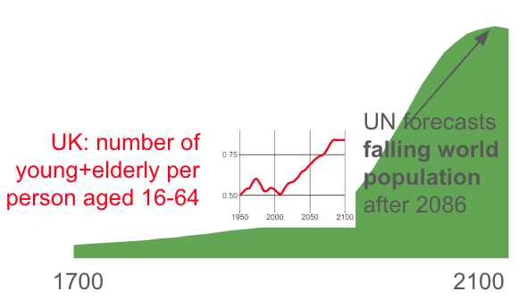
- Figure 1: The graph shows the increasing human population since 1700, forecast to peak in 2086. Inset: A graph showing the ratio of young (<16) and elderly (65+) people to working-age people (16-64) increasing from 0.5 in 1950 to an estimated 0.85 in 2100.
Note from Jenny — for our children, the concern is not so much that robots will take their jobs, but that robots won’t have developed enough to fill the gap

- Embodied intelligence or morphological computing is a distinctive feature of biological systems. In flying insects, the wingbeat frequency reflects the body’s resonant frequency, while muscles inject energy each beat through their mechanical properties. Control is simplified because signals do not need to be timed precisely. Note from Jenny — could we make a material with the stress/strain relationship of active insect asynchronous flight muscle?
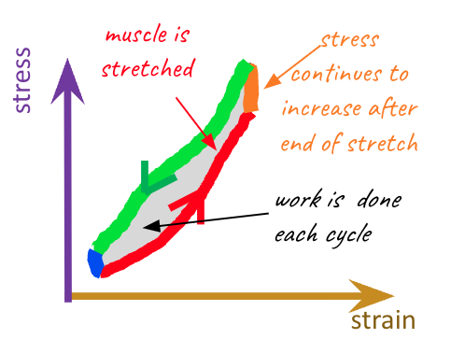
- The graph shows the work loop of insect flight muscle. The graph shows how stress not only increases as strain increases, but continues to increase even after the end of the stretch. This means that the area enclosed within the work loop is >0 and so work is done each cycle.

- Animal bodies have a protective, flexible, waterproof, washable, self-healing covering densely studded with sensors for pressure, temperature and tissue damage - skin.

- Muscle has incredible properties - tunable stiffness, variable recruitment, and the ability to absorb as well as generate work, enabling it to switch between roles such as actuation, structural bracing and shock absorption.
Note from Jenny - both have intelligent sensing and actuation. What would it take to create something similar for robots?
- The image is a cutaway diagram of human skin, showing the different layers and the multitude of different sensors embedded within them.

- Currently, humans tele-operating robotic hardware outperform autonomous systems on complex tasks in unpredictable environments, showing that inadequate control algorithms are the current bottleneck. Note from Jenny - the next bottlenecks will be the affordability and reliability of robotic hardware, the amount of compute required for complex control, and energy consumption.

- Jointly optimising control, materials and body design could unlock higher performance while making better use of available power and compute. Together, these are the keys to producing robots with the capabilities we need.

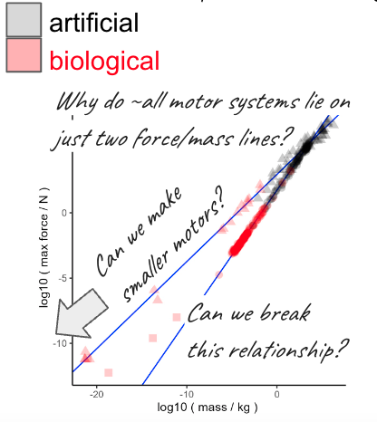
- The graph plots the maximum force exerted by a motor as a function of motor mass, for many different examples of motors, both artificial (e.g. jet engine) and biological (e.g. muscle). Most of the points lie on just two straight lines on log-log axes, implying that some sort of physical “law” constrains the force generated by motors of very different types. It’s also noticeable that the artificial motors tend to be much heavier than the biological motors, raising the question of whether we could build tiny artificial motors for powering robots.
Note from Jenny — Can we break this relationship? Can we make smaller motors?
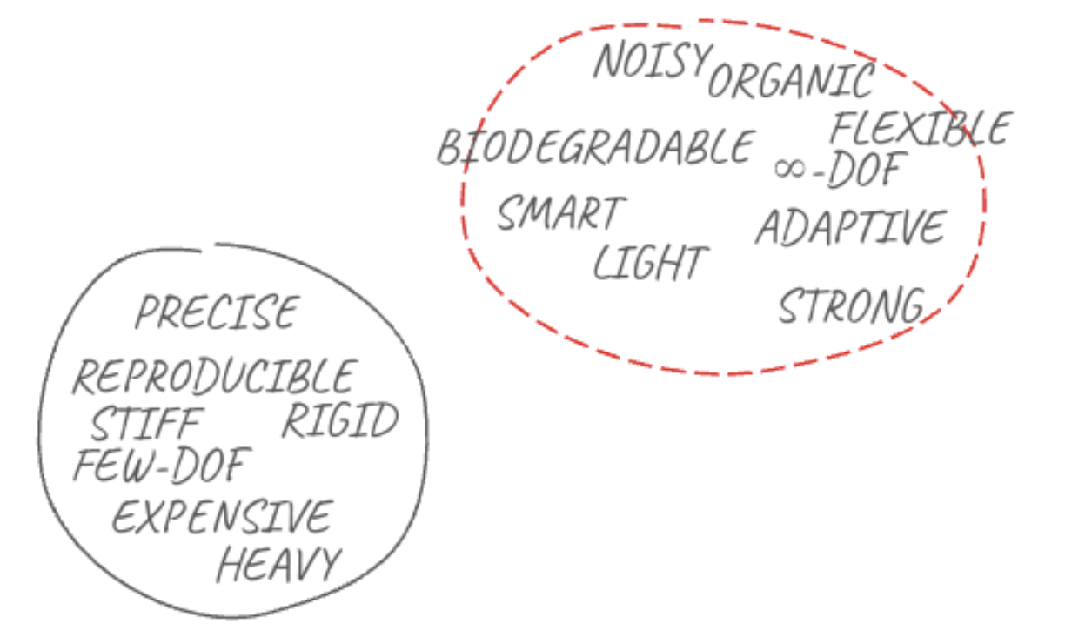
- This is a sketch illustrating the ideas put forward in the text. One circle represents the previously accessible design space, characterised by components that are precise, stiff, rigid, expensive, heavy, have few degrees of freedom, and make highly reproducible movements. Another circle suggests the opportunity space opened up by recent advances: including components which might be flexible, with potentially infinitely many degrees of freedom, noisy, organic, biodegradable, smart, adaptive and light but strong.

SOURCES
A compiled, but not exhaustive list of works helping to shape our view and frame the opportunity space (for those who want to dig deeper).

- Humanity has long dreamt of robot servants and guardians
- Our grandchildren will inherit a world where the population is falling (Figure 1)
- Dependency ratios will approach 1 by the end of the century (Figure 1 inset)
- Today’s robots lack the adaptivity,robustness, versatility, and agility of biological organisms
- Insect intelligence offers an alternative to classic methods in robotics
- What can robotics learn from neuromechanics?
- Currently-available soft actuators are very different from muscle
- Insect asynchronous flight muscle has remarkable properties (Figure 2)
- There may be universal scaling laws applying to all motors (Figure 3)
- Insect flight motors are extraordinary natural structures that maintain near-perfect resonant energetic optimality over significant wingbeat frequency range
- Animal integumentary systems are highly sophisticated (Figure 4)

ENGAGE
We invite you to shape our efforts by providing feedback and surfacing breakthrough ideas related to this opportunity space. Our next step will be to formulate a programme that directs funding across research disciplines or institutions towards a focus objective. We also plan to open up seed funding for researchers whose bold aspirations are unlikely to be funded elsewhere.

Sign up for updates and share your feedback here [www.aria.org.uk/contact-jenny]. You can upload a short pdf — we will read anything you send.

