Programmable Plants — A technology platform for sustainable abundance
Opportunity space

v1.0
Angie Burnett, Programme Director

CONTEXT

This document describes an early opportunity space from which we believe one or more funding programmes can emerge. We’ve sketched out some of our early thinking to spark your interest, and invite you to imagine relevant potential programmes with us, or suggest new directions. We’ll publish updated versions of this document as our thinking evolves. Sign up here [www.aria.org.uk/contact-angie] to receive those updates and learn about any funding opportunities that emerge from this opportunity space.

An ARIA opportunity space should be:
+important if true (i.e. could lead to a significant new capability for society),
+under-explored relative to its potential impact, and
+ripe for new talent, perspectives, or resources to change what’s possible.

Plants have paved the way for human existence and hold tremendous potential to solve some of our most pressing challenges such as food insecurity, climate change and environmental degradation. Programmable plants can secure our future on earth - providing not just food, but a sustainable and thriving biosphere for future generations.

BELIEFS
The core beliefs that underpin/bound this area of opportunity.

1. Today’s agricultural system is struggling to address the coupled challenges of sustainable food supply and stable climate → we need a paradigm shift to accelerate agricultural innovation.

2. Plants represent 80% of earth’s biomass and are rapidly, cost-effectively and widely distributed across our planet → plants represent an ideal technological platform to provide low-cost, sustainable resources at scale.

3. Advances in gene editing and genetic modification are revolutionising our ability to tailor the traits of organisms → we can predictably and efficiently develop amazing new plants to provide all of society with abundant and sustainable resources: food, fuel, medicine, shelter and beyond.

OBSERVATIONS
Some signposts as to why we see this area as important, under-served, and ripe.

- Climate change, especially the uncertainty and severity of extreme weather events, is stressing the global agrifood system. Plant engineering can both mitigate the stress and help address the root cause.

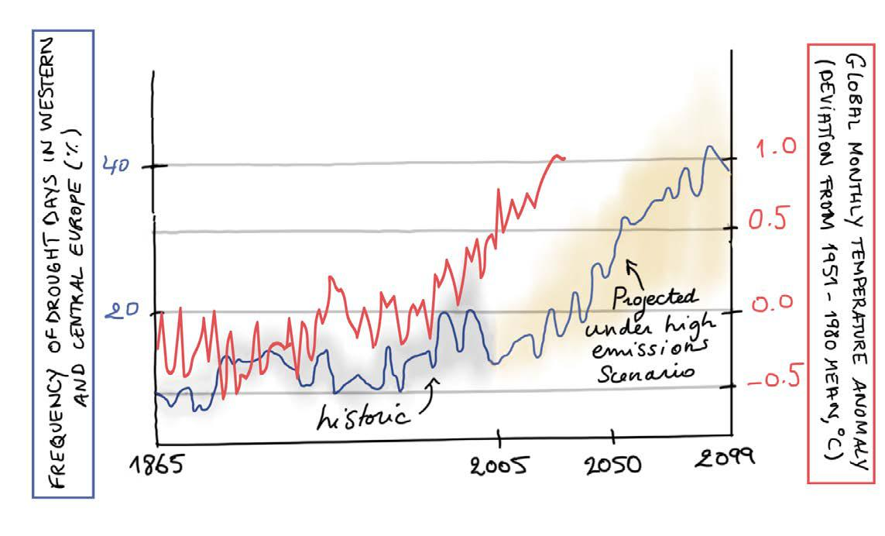
- Figure 1: A graph that shows trends in increasing frequency of drought and increasing temperature.

- It typically takes eight years to develop a new crop variety in the UK. During the COVID-19 pandemic, we made a vaccine in one year instead of ten.
Note from Angie – How can we similarly fast-track crop development to stay abreast of our changing climate?

- Crop optimisation has historically been limited by trade-offs between yield and resilience. We know of mechanisms to regulate these tradeoffs (e.g. hormonal intervention by fungal endophytes), but how can we overcome them?

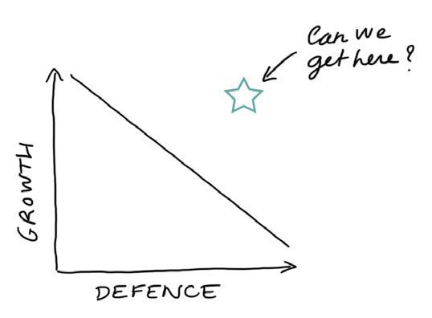
- Figure 2: A graph that shows the trade-off between growth and defence, and the proposed ideal of high growth and high defence.
Note from Angie – In the future we’ll design, write and build fully synthetic crop genomes.

- De novo pathways and fully synthetic de novo organism synthesis including a minimal genome have been proven in bacteria.

- In the short term, we could develop synthetic plant chromosomes and chloroplasts in vivo that will transfer gene modules into crops to deliver specific functionalities.

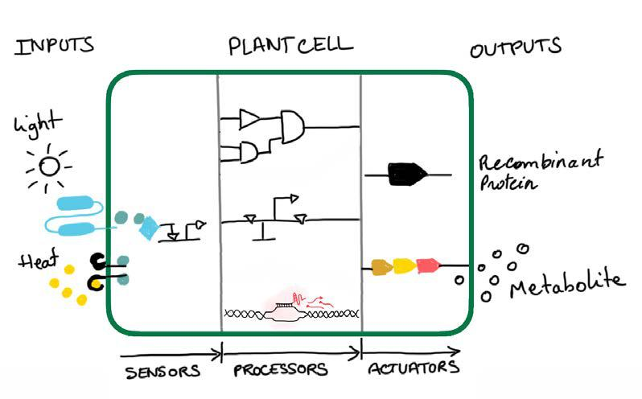
- Figure 3: A diagram of an engineered plant cell showing how inputs such as light and heat can be processed via logic gates, memory and signal amplification to produce outputs such as recombinant proteins and metabolites.

- Target and network discovery are needed to make synthetic chromosomes and chloroplasts effective in multiple species. Breakthroughs are needed for centromere formation for bottom-up synthetic chromosomes, since centromere formation in plant cells is under epigenetic control.

- Transformation - the incorporation of new genes into plants - enables us to add and change plant functions. Tissue culture is a major bottleneck that limits transformation speed and transferability between species. The regeneration phase for plant material in tissue culture can take months.

- Gene editing using CRISPR is faster and more precise than genetic modification, and increases the predictability of phenotypes ten-fold.
Note from Angie – Moving out of tissue culture would be huge!

- Revolutionising transformation would unlock the power of gene editing, providing major benefits to breeding and research. We need a method that is high-yielding, transferable between species and does not rely on tissue culture.
Note from Angie – Emergent possibilities include meristems and pollen targets. Directly editing seeds could be on the horizon!

- A transferable transformation method would enable greater use of orphan crops and crop wild relatives to increase diversity and resilience.

- AI can guide edits and select transformed plants but we need innovations in method development to streamline design.

- For transient in-field adaptations, viral delivery of genetic material can transform crops.
Note from Angie – Can we develop a universal transient gene expression method?

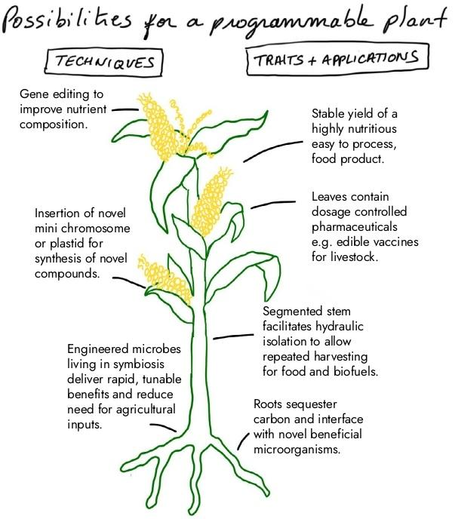
- Figure 4: A diagram of possibilities for a programmable plant, showing how different techniques could be applied to produce different traits and applications. The diagram has some notes from Angie outlining possible techniques and traits of a programmable plant –
Techniques include: gene editing to improve nutrient composition; insertion of novel mini chromosome on plastid for synthesis of novel compounds; and engineered microbes living in symbiosis deliver rapid, tunable benefits and reduce need for agricultural inputs.
Traits and applications include: stable yield of a highly nutritious, easy to process, food product; leaves contain dosage controlled pharmaceuticals e.g. edible vaccines for livestock; segmented stem facilitates hydraulic isolation to allow repeated harvesting for food and biofuels; and roots sequester carbon and interface with novel beneficial microorganisms.

SOURCES
A compiled, but not exhaustive list of works helping to shape our view and frame the opportunity space (for those who want to dig deeper).

- UNFAO: The State of Food Security and Nutrition in the World 2023
- IPCC: Sixth Assessment Report on Climate Change

The timing of unprecedented hydrological drought under climate change (Figure 1)
- Climate change impacts data (Figure 1)
- Feeding the world: improving photosynthetic efficiency for sustainable crop production
- Global change and vegetation
- The new frontier of genome engineering with CRISPR
- Gene editing using TAL effector nucleases
- Genetic Technology (Precision Breeding) Act 2023
- Recent advances in crop transformation technologies
- Advances in delivery mechanisms of CRISPR gene-editing reagents in plants
- How to build a genome
- Plant chromosome engineering
- DNA synthesis technologies to close the gene writing gap
- First synthetic bacterium
- Plant gene editing through de novo induction of meristems
- Organelle-targeted gene delivery in plants by nanomaterials
- Plant virus-derived vectors for plant genome engineering
- The design of synthetic gene circuits in plants (Figure 3)
- Minimising and re-functionalising genomes using synthetic biology

ENGAGE
We invite you to shape our efforts by providing feedback and surfacing breakthrough ideas related to this opportunity space. Our next step will be to formulate a programme that directs funding across research disciplines or institutions towards a focus objective. We also plan to open up seed funding for researchers whose bold aspirations are unlikely to be funded elsewhere.

Sign up for updates and share your feedback here [www.aria.org.uk/contact-angie]. You can upload a short pdf — we will read anything you send.
If you require an accessible version of this document and/or form, please contact us at info@aria.org.uk.

