Precision Neurotechnologies for Human Therapeutics
Programme thesis

v1.0
Jacques Carolan, Programme Director

CONTEXT
This document presents the core thesis underpinning a programme that is currently in development at ARIA. We share an early formulation and invite you to provide feedback to help us refine our thinking.

This is not a funding opportunity, but in most cases will lead to one. Sign up here to provide feedback, register your interest in joining a team, or to learn about any funding opportunities derived from this programme thesis.

An ARIA programme seeks to unlock a scientific or technical capability that:

- Changes the perception of what’s possible or valuable.
- Has the potential to catalyse massive social and economic returns.
- Is unlikely to be achieved without ARIA’s intervention.

PROGRAMME THESIS, SIMPLY STATED
This programme thesis is derived from the ARIA Opportunity Space: Precisely interfacing with the human brain at scale.

By developing tools to interface with the human brain with unprecedented precision, this programme will unlock new therapeutic methods to understand, identify and treat neurological and neuropsychiatric disorders.

Brain disorders are the cause of an overwhelming social and economic burden: in 2019 they accounted for 21% of the global disease burden (compared with 7% for coronary heart disease), costing an estimated 530M disability adjusted life-years (DALYs) [1, 2].

Many of these conditions are disorders of neural circuits, involving a diversity of cell type, distributed across different brain regions, and with complex temporal dynamics. This programme aims to develop new tools that can interact with the central nervous system at the circuit-level to understand the onset and progression of disease, identify biomarkers of disease states and ultimately to treat these disorders.

PROGRAMME THESIS, EXPLAINED
A detailed description of the programme thesis, presented for constructive feedback

Why this programme
It is becoming increasingly evident that targeted interaction with the human nervous system can improve the human condition across an incredibly wide range of disease states and cognitive domains. An existence proof is deep brain stimulation (DBS), which has been approved by the U.S. Food and Drug Administration to treat movement disorders such as Parkinson’s disease and essential tremor [3], and neurological disorders such as epilepsy [4]. Emerging work suggests DBS can be effective for a much wider range of treatments than previously envisioned, including treatment resistant depression [5], mood and anxiety disorders [6], substance addiction [7] and potentially even Alzheimer’s disease [8]. In total, this points towards a vast pool of the population that could benefit from neurotechnologies.

While neurotechnologies have improved the quality of life for hundreds of thousands of people worldwide, these technologies have yet to see broad adoption. There are many factors at play, including regulatory barriers, healthcare economics, clinical adoption and patient hesitancy [9]. We believe that the development of precision neurotechnologies, able to provide significantly more personalised and effective treatment to a much wider patient population, will be the critical factor in overcoming these barriers and driving downstream adoption.

Our theory of change is that circuit-level neurotechnologies (Figure 1), with the ability to read and write cell type specific information across distributed brain regions, will yield breakthroughs in: (1) disease understanding and diagnosis by generating novel, multi-modal data sets of the brain during disease onset, disease progression and in health, which will lead to novel biomarkers of disease; (2) the identification of novel therapeutic targets with either well understood mechanisms of action or AI derived patterns of modulation that target specific circuit elements; and (3) personalised treatments by building patient specific models of brain disorders that account for disease heterogeneity, enabling interventions tailored to the individual.

This new paradigm of precision neurotechnology (borrowing terminology from the field of precision medicine [10], see also [11]) can avoid many of the challenges of existing coarse grain interventions such as DBS or pharmaceuticals. Here, the mechanism of action is often unclear [12], which coupled with significant disease heterogeneity [13] leads to challenges in determining the eligibility of patients for a particular treatment, variable patient outcomes when these treatments are administered [14] and poorly understood side effects related to the treatment [15]. By uniting the frontiers of engineered biology with engineered hardware, we believe precision neurotechnologies can alleviate the bottlenecks with existing therapies and unlock significantly more effective treatments for a wider array of brain disorders.

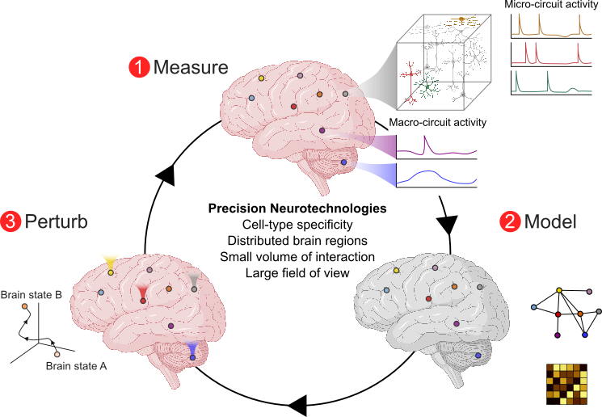

Figure 1. The figure shows three depictions of a human brain at several stages in a loop. In the centre of the loop is a caption which gives the heading ‘Precision Neurotechnologies’ with the text underneath which is “Cell-type specificity, Distributed brain regions, Small volume of interaction, Large field of view” The loop starts with 1. Measure (recording brain activity with a neurotechnology to record micro- and macro-circuit activity) and shows a graph of activity versus time as an output, then 2. Model (using new computer models to map and predict brain states based on the recordings taken in number 1) and then 3. Perturb (using neurotechnologies to alter brain states modelled in number 2 also depicting a graph showing the transition from brain state A to brain state B) with the loop finally feeding back into 1. Measure to repeat the cycle.

Figure caption: Precision neurotechnologies can enable (1) a new lens into the functioning of the human brain, across brain regions (macro-circuits) and within brain regions (micro-circuits). This data will form the basis for (2) new models of the brain during disease states and in health which will enable the identification of (3) novel therapeutic targets to drive from brain state A (e.g. awake, seizure, tremor) to brain state B (e.g. sleep, non-seizure, restored motor function).

Circuit-level brain disorders
“The brain is a highly complex, interconnected network that balances regional segregation and specialization of function with strong integration; a balance that gives rise to complex and precisely coordinated dynamics across multiple spatiotemporal scales” [16]. We define a circuit-level disorder to be one where there is dysfunction between these interconnected brain regions (macro-circuits) or within a brain region (micro-circuits). Many of the most complex and common neuropsychiatric disorders are now thought to be disorders of circuits [17] (e.g. post-traumatic stress disorder [18], mood and anxiety disorders [6], Schizophrenia [19]). Indeed, even if the disorder is known to be focal in origin (e.g. neurodegenerative disorders, stroke, focal epilepsy), connectivity between brain regions can often drive the pathology [20].

Alongside connectivity between and within brain regions, another key circuit element is cell type. The human brain consists of billions of neurons that are organised into thousands of different cell types, each with distinct morphological, transcriptomic and functional properties. Due to advances in single-cell transcriptomics, we are now beginning to understand the full diversity of cell types in the human brain [21]. Neurons of different cell types within close proximity can drive radically different downstream functions and behaviours [22], and distinct cell types are often involved in disorders. For example, disordered micro-circuit motifs involving excitatory and inhibitory neurons have been implicated in certain forms of epilepsy [23].

Understanding the circuitry underlying disorder has given tantalising insights into new therapeutic interventions. For example, modulation of distinct neuronal subpopulations in the basal ganglia gave rise to longer lasting attenuation of motor symptoms in mouse models of Parkinson's disease compared with conventional ‘bulk’ neuromodulation [24], and cell type specific modulation of superficial cortical regions reproduced many of the therapeutic effects of DBS, without requiring a deeply implanted electrode [25]. In sum, circuit-level understanding of the brain points the way towards more effective and less invasive therapies [26], which we believe will be further accelerated by advances in artificial intelligence to correlate circuit-level activity with biomarkers of disease states, alongside advances in bioengineering, which will enable cell type specific interfacing.

What we expect to fund
We anticipate funding a variety of institutions (e.g. academic research groups, startups, established industry) across three broad technical areas:
- Technical Area 1 (TA1) which is focused on the development of next-generation precision neurotechnologies (estimated budget: £2–4M per project over four years).
- Technical Area 2 (TA2) which is focused on applying precision neurotechnologies to demonstrate the controllable transition between brain states (estimated budget: £8–10M per project over four years).
- Technical Area 3 (TA3) which is focused on patient and stakeholder engagement related to the development of precision neurotechnologies (estimated budget: £300k per project over one year).

Development of next-generation precision neurotechnologies (TA1)
The primary goal of this technical area is to develop a suite of next-generation precision neurotechnologies to enable circuit-level access to the brain, with cell type specificity and across distributed macro- and micro-brain circuits. In Annex 1 we have identified a number of key performance metrics that should be optimised to achieve circuit-level neural interfaces, which will be the target of TA1. By the end of this technical area, teams should have demonstrated the fundamental principle of operation (including ground truth validation), designed and developed a miniaturised prototype (if the technology is device based) and demonstrated successful operation in vivo. Technologies which fundamentally rely on large-scale facilities (e.g. MRI, benchtop microscopy) will likely be out of scope, as will incremental advances of existing technologies.

A key principle of this technical area is that we fund a broad portfolio of breakthrough early stage technologies, including approaches that may not traditionally be considered ‘neurotechnologies’ such as those based on advances in bioengineering. Approaches may include, but are not limited to:

- Bio-hybrid approaches including those based on functionalised bioelectronics [27] or stem cells [28].
- Cell type specific gene therapies [29].
- Blood based neuromodulation (e.g. chemogenetics [30]) and neuromonitoring [31].
- Nanotransducer networks controlled by external magnetic, optical, or acoustic fields [32].
- Next-generation focused ultrasound systems with cell type specific [33], multi-site [34] and/or spatially precise [35] neuromodulation and recording.
- Other ideas!

Even though we are developing early stage technologies, we believe there are a number of steps that can be taken at this early stage to support the ultimate goal of clinical translation. We therefore require teams to:

- Consider how their technologies will be used with humans, e.g. by leveraging novel surgical or delivery methods including (but not limited to) injectables [36], skull implants (compatible with standard burr hole geometries) [37], endovascular stents [38] and considering potential explantability.
- Specify the particular condition they anticipate applying their technology to and outline the performance metrics that need to be met in Annex 1. This is not meant to be binding and if new performance capabilities emerge during the course of the programme, ARIA will work with teams to refine their technology for different conditions.
- Assess and report the safety of their technology via standardised histology and toxicology tests [39, 40], as well as the longevity of their device via performance tests over time [41]. ARIA intends to maintain and publish a database of safety reports for the wider neurotechnology community.

This technical area is designed to develop high performance technology options, so we anticipate teams focusing on novel one-way (readout or modulation) approaches. However, we will also consider technologies that can be used bidirectionally (readout and modulation), provided the combination doesn’t sacrifice performance. If teams propose a neuromodulatory technology, it must be able to be controlled by an exogenous signal (e.g. to dose the treatment) or an endogenous signal (e.g. closed-loop operation based on neural activity or behaviour) and dose-response curves and readout-modulation latencies must be carefully characterised.

Applying precision neurotechnologies (TA2)
While the overall goal of the programme is technological, we strongly believe that to yield the greatest impact precision neurotechnologies should be integrated into a measure-model-perturb cycle (see Figure 1) to demonstrate fundamentally new therapeutic capabilities. We therefore plan to support multiple interdisciplinary teams to develop and leverage precision neurotechnologies to demonstrate the controllable, predictable and reversible transition between novel brain states, in vivo.

Recent work has shown it is possible to model the dynamics of brain networks and predict the effects of targeted electrical modulation [42]. The goal of this technical area is to go beyond prediction by using data-driven models to generate new modulation patterns that can transition to a desired brain state (see e.g. [43] for a working description of ‘brain state’). The driver here is to change the conversation about what is possible with precision neurotechnologies. We therefore want teams to demonstrate a capability that is fundamentally not possible with existing approaches, such as transitioning the brain to out-of-manifold states that do not occur endogenously or device-mediated plasticity to route around focal injury (for example due to stroke).

Teams applying to this technical area should incorporate the necessary systems development (e.g. neuroengineers, bioengineers), computational neuroscientists and modelling efforts, experimental neuroscientists and potentially even a clinical partner. Teams should select the particular set of brain states they wish to focus on, provided the states can be well defined, the transition between states verified via ground truth methods and that the transition is reversible. We particularly encourage brain states with relevance to neurological and neuropsychiatric conditions, although acknowledge the limitation of suitable models for many of these disorders. Potential examples may include, but are not limited to: seizure to non-seizure states, awake to sleep states, tremor to restored motor function states. Where demonstrations relate to brain states that are already the target of existing therapeutics (e.g. DBS for movement disorders) teams must show a capability that significantly advances the state-of-the-art in terms of energy efficiency, the mitigation of side effects, longer lasting therapeutic benefits or less invasive (i.e. more superficial) modulation targets.

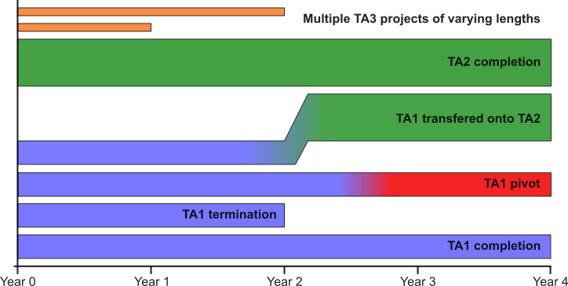

Figure 2. Shows a horizontal bar chart depicting several technical areas of a project on the Y-axis over a period of 4 years with years displayed on the x axis.

Figure Caption: Potential programme structure with possible project outcomes
(note: not representative of the number of projects expected to be selected).

As this technical area has more demanding in vivo requirements than TA1, we anticipate proposed technologies may include refinements, augmentation and miniaturisation of technologies whose fundamental principle of operation may have already been demonstrated. However, we are looking for radically new technology systems and not the direct application of existing technologies. If advances are made particularly fast in TA1, we will also consider TA1 teams moving onto the TA2 track (see Figure 2).

As in TA1, we require teams to design and develop a portable system and consider the translation goals described above. In addition, to support the clinical translation of these technologies, we anticipate the final demonstration may be in a non-mouse animal model. Even though the key driver of the overall programme is to develop breakthrough technologies we will consider applications whose goal is to reach first-in-human by the end of a four-year programme, provided this doesn’t sacrifice technology performance.

We expect TA2 to yield breakthroughs in computational methods, for example in network theory [44], optimal control theory [45], linear dynamical systems [43] or nonlinear dynamical systems [46], and conjecture that cell type specific signals [47] distributed across distinct brain regions [46] will be critical for building accurate and practical models of the brain.

Patient and broader stakeholder engagement into advanced neurotechnologies (TA3)
During the scoping for this programme, we identified a gap in the literature for patient engagement related to advanced neurotechnologies. Specifically, we found little published work around what levels of intrusion into their life people with lived experiences of neurological and neuropsychiatric disorders are willing to accept, and how this trades off for a particular therapeutic benefit. This will be critical when designing next-generation precision neurotechnologies. We therefore plan to solicit applications for specialised teams willing to undertake patient engagement, and also engagement with stakeholders more broadly across the ecosystem: e.g. family members and other long-term caregivers, clinicians (including those on the referral path), surgeons and regulators. The results of this work will be shared with the wider neurotechnology community.

What we are still trying to figure out
- In Annex 1 we identify a number of metrics that are critical for circuit-scale neural interfaces. What have we missed?
- We have provided estimates of project costs under ‘what we expect to fund’. Are these reasonable? If not, tell us why. Any information about expected cost breakdowns will be critical in helping us plan our budget.
- TA2 requires the formation of multidisciplinary teams. If individual groups need help forming these larger teams, in response to the programme thesis, we are allowing groups who need help teaming to register their capabilities and what expertise they are missing. ARIA is working to develop a system for sharing capability gaps with other registered teams to support matching.
- We welcome input from teams about how best to support the clinical translation of these technologies, setting out what models (including potential non-mouse models) may be most appropriate, and whether teams have the ability to facilitate this. Note that ARIA- funded research must comply with the principles of the 3Rs.
- We want a standardised set of tests to assess the safety and efficacy over time of all technologies developed during this programme. Given this is an active area of research and that funded technologies will likely be highly diverse (e.g. from novel electrodes to gene therapies), what are the right tests to use? Are there contract research organisations (CROs) ARIA can support to do this work?
- Are there facilities or capabilities ARIA could support, which would be beneficial for many teams within the programme? For example manufacturing capabilities, regulatory support or computational resources.

SOURCES
References cited in this document.

[1] G. Deuschl et al., “The burden of neurological diseases in Europe: an analysis for the Global Burden of Disease Study 2017,” The Lancet Public Health, vol. 5, no. 10, pp. e551–e567, Oct. 2020, doi: https://doi.org/10.1016/s2468-2667(20)30190-0.
[2] M. Cvitkovic, “Cause Area: Differential Neurotechnology Development,” Effective Altruism Forum, Aug. 2020, Accessed: Mar. 01, 2024. [Online]. Available: https://forum.effectivealtruism.org/posts/Qhn5nyRf93dsXodsw/cause-area-differential-neurotechnology-development
[3] “Deep brain stimulation (DBS) for the treatment of Parkinson’s disease and other movement disorders | National Institute of Neurological Disorders and Stroke,”. https://www.ninds.nih.gov/about-ninds/what-we-do/impact/ninds-contributions-approved-therapies/deep-brain-stimulation-dbs-treatment-parkinsons-disease-and-other-movement-disorders#:~:text=Based%20on%20results%20from%20a (accessed Mar. 01, 2024).
[4] “Brain stimulation therapies for epilepsy | National Institute of Neurological Disorders and Stroke,”https://www.ninds.nih.gov/about-ninds/what-we-do/impact/ninds-contributions-approved-therapies/brain-stimulation-therapies-epilepsy#:~:text=The%20FDA%20approves%20two%20new (accessed Mar. 01, 2024).
[5] S. Alagapan et al., “Cingulate dynamics track depression recovery with deep brain stimulation,” Nature, vol. 622, no. 130–138, pp. 1–9, Sep. 2023, doi: https://doi.org/10.1038/s41586-023-06541-3.
[6] K. J. Ressler and H. S. Mayberg, “Targeting abnormal neural circuits in mood and anxiety disorders: from the laboratory to the clinic,” Nature Neuroscience, vol. 10, no. 9, pp. 1116–1124, Aug. 2007, doi: https://doi.org/10.1038/nn1944.
[7] J. Luigjes et al., “Deep brain stimulation in addiction: a review of potential brain targets,” Molecular Psychiatry, vol. 17, no. 6, pp. 572–583, Sep. 2011, doi: https://doi.org/10.1038/mp.2011.114.
[8] S. Hescham, “Deep Brain Stimulation for Alzheimer’s Disease an Update,” surgicalneurologyint.com, Mar. 07, 2018. https://surgicalneurologyint.com/surgicalint-articles/deep-brain-stimulation-for-alzheimers-disease-an-update/ (accessed Mar. 01, 2024).
[9] D. A. Borton, H. E. Dawes, G. A. Worrell, P. A. Starr, and T. J. Denison, “Developing Collaborative Platforms to Advance Neurotechnology and Its Translation,” Neuron, vol. 108, no. 2, pp. 286–301, Oct. 2020, doi: https://doi.org/10.1016/j.neuron.2020.10.001.
[10] G. S. Ginsburg and K. A. Phillips, “Precision Medicine: From Science To Value,” Health Affairs, vol. 37, no. 5, pp. 694–701, May 2018, doi: https://doi.org/10.1377/hlthaff.2017.1624.
[11] S. R. Patel and C. M. Lieber, “Precision electronic medicine in the brain,” Nature biotechnology, vol. 37, no. 9, pp. 1007–1012, 2019, doi: https://doi.org/10.1038/s41587-019-0234-8.
[12] T. M. Herrington, J. J. Cheng, and E. N. Eskandar, “Mechanisms of deep brain stimulation,” Journal of Neurophysiology, vol. 115, no. 1, pp. 19–38, Jan. 2016, doi: https://doi.org/10.1152/jn.00281.2015.
[13] A. Segal et al., “Regional, circuit and network heterogeneity of brain abnormalities in psychiatric disorders,” Nature Neuroscience, vol. 26, no. 1613–1629, pp. 1–17, Aug. 2023, doi: https://doi.org/10.1038/s41593-023-01404-6.
[14] P. Vicheva, M. Butler, and P. Shotbolt, “Deep brain stimulation for obsessive-compulsive disorder: A systematic review of randomised controlled trials,” Neuroscience & Biobehavioral Reviews, vol. 109, pp. 129–138, Feb. 2020, doi: https://doi.org/10.1016/j.neubiorev.2020.01.007.
[15] M. Z. Zarzycki and I. Domitrz, “Stimulation-induced side effects after deep brain stimulation – a systematic review,” Acta Neuropsychiatrica, vol. 32, no. 2, pp. 1–8, Aug. 2019, doi: https://doi.org/10.1017/neu.2019.35.
[16] A. Fornito, A. Zalesky, and M. Breakspear, “The connectomics of brain disorders,” Nature Reviews. Neuroscience, vol. 16, no. 3, pp. 159–172, Mar. 2015, doi: https://doi.org/10.1038/nrn3901.
[17] S. H. Siddiqi et al., “Brain stimulation and brain lesions converge on common causal circuits in neuropsychiatric disease,” Nature Human Behaviour, vol. 5, no. 12, pp. 1707–1716, Dec. 2021, doi: https://doi.org/10.1038/s41562-021-01161-1.
[18] R. J. Fenster, L. A. M. Lebois, K. J. Ressler, and J. Suh, “Brain circuit dysfunction in post-traumatic stress disorder: from mouse to man,” Nature Reviews Neuroscience, vol. 19, no. 9, pp. 535–551, Jul. 2018, doi: https://doi.org/10.1038/s41583-018-0039-7.
[19] O. Howes, B. R. Bukala, and K. Beck, “Schizophrenia: from neurochemistry to circuits, symptoms and treatments,” Nature Reviews Neurology, vol. 20, no. 22–35, Dec. 2023, doi: https://doi.org/10.1038/s41582-023-00904-0.
[20] J. W. Vogel et al., “Connectome-based modelling of neurodegenerative diseases: towards precision medicine and mechanistic insight,” Nature Reviews Neuroscience, vol. 24, no. 10, pp. 620–639, Oct. 2023, doi: https://doi.org/10.1038/s41583-023-00731-8.
[21] K. Siletti et al., “Transcriptomic diversity of cell types across the adult human brain,” Science, vol. 382, no. 6667, Oct. 2023, doi: https://doi.org/10.1126/science.add7046.
[22] H. J. Lee et al., “Activation of Direct and Indirect Pathway Medium Spiny Neurons Drives Distinct Brain-wide Responses,” Neuron, vol. 91, no. 2, pp. 412–424, Jul. 2016, doi: https://doi.org/10.1016/j.neuron.2016.06.010.
[23] J. T. Paz and J. R. Huguenard, “Microcircuits and their interactions in epilepsy: is the focus out of focus?,” Nature Neuroscience, vol. 18, no. 3, pp. 351–359, Feb. 2015, doi: https://doi.org/10.1038/nn.3950.
[24] T. A. Spix et al., “Population-specific neuromodulation prolongs therapeutic benefits of deep brain stimulation,” Science, vol. 374, no. 6564, pp. 201–206, Oct. 2021, doi: https://doi.org/10.1126/science.abi7852.
[25] S. Valverde et al., “Deep brain stimulation-guided optogenetic rescue of parkinsonian symptoms,” Nature Communications, vol. 11, no. 1, May 2020, doi: https://doi.org/10.1038/s41467-020-16046-6.
[26] B. Hollunder et al., “Mapping dysfunctional circuits in the frontal cortex using deep brain stimulation,” Nature Neuroscience, pp. 1–14, Feb. 2024, doi: https://doi.org/10.1038/s41593-024-01570-1.
[27] A. Zhang, T. J. Zwang, and C. M. Lieber, “Biochemically functionalized probes for cell-type–specific targeting and recording in the brain,” Science Advances, vol. 9, no. 48, Dec. 2023, doi: https://doi.org/10.1126/sciadv.adk1050.
[28] D. O. Adewole et al., “Development of optically controlled ‘living electrodes’ with long-projecting axon tracts for a synaptic brain-machine interface,” Science Advances, vol. 7, no. 4, p. eaay5347, Jan. 2021, doi: https://doi.org/10.1126/sciadv.aay5347.
[29] L. T. Graybuck et al., “Enhancer viruses for combinatorial cell-subclass-specific labeling,” Neuron, vol. 109, no. 9, pp. 1449-1464.e13, May 2021, doi: https://doi.org/10.1016/j.neuron.2021.03.011.
[30] M. C. Walker and D. M. Kullmann, “Optogenetic and chemogenetic therapies for epilepsy,” Neuropharmacology, vol. 168, p. 107751, May 2020, doi: https://doi.org/10.1016/j.neuropharm.2019.107751.

[31] S. Lee et al., “Engineered serum markers for non-invasive monitoring of gene expression in the brain,” Nature Biotechnology, pp. 1–9, Jan. 2024, doi: https://doi.org/10.1038/s41587-023-02087-x.

[32] D. Seo et al., “Wireless Recording in the Peripheral Nervous System with Ultrasonic Neural Dust,” Neuron, vol. 91, no. 3, pp. 529–539, Aug. 2016, doi: https://doi.org/10.1016/j.neuron.2016.06.034.
[33] K. J. Murphy et al., “A tool for monitoring cell type–specific focused ultrasound neuromodulation and control of chronic epilepsy,” vol. 119, no. 46, Nov. 2022, doi: https://doi.org/10.1073/pnas.2206828119.
[34] G. Li et al., “Imaging Guided DualTarget Neuromodulation of the Mouse Brain Using Array Ultrasound,” IEEE Transactions on Ultrasonics, Ferroelectrics, and Frequency Control, vol. 65, no. 9, pp. 1583–1589, doi: https://doi.org/10.1109/TUFFC.2018.2847252.
[35] Y. Li et al., “Optically-generated focused ultrasound for noninvasive brain stimulation with ultrahigh precision,” Light: Science & Applications, vol. 11, no. 1, p. 321, Nov. 2022, doi: https://doi.org/10.1038/s41377-022-01004-2.
[36] G. Hong, T.-M. Fu, T. Zhou, T. G. Schuhmann, J. Huang, and C. M. Lieber, “Syringe Injectable Electronics: Precise Targeted Delivery with Quantitative Input/Output Connectivity,” Nano Letters, vol. 15, no. 10, pp. 6979–6984, Sep. 2015, doi: https://doi.org/10.1021/acs.nanolett.5b02987.
[37] J. E. Woods et al., “Millimeter sized battery free epidural cortical stimulators,” medRxiv, p. 2023.09.13.23295460, Jan. 2023, doi: https://doi.org/10.1101/2023.09.13.23295460.
[38] T. J. Oxley et al., “Minimally invasive endovascular stent-electrode array for high-fidelity, chronic recordings of cortical neural activity,” Nature Biotechnology, vol. 34, no. 3, pp. 320–327, Mar. 2016, doi: https://doi.org/10.1038/nbt.3428.
[39] A. T. Rajan et al., “The effects of chronic intracortical microstimulation on neural tissue and fine motor behavior,” Journal of Neural Engineering, vol. 12, no. 6, p. 066018, Oct. 2015, doi: https://doi.org/10.1088/1741-2560/12/6/066018.
[40] C. for D. and R. Health, “Implanted Brain-Computer Interface (BCI) Devices for Patients with Paralysis or Amputation - Non-clinical Testing and Clinical Considerations,” U.S. Food and Drug Administration, May 17, 2021. https://www.fda.gov/regulatory-information/search-fda-guidance-documents/implanted-brain-computer-interface-bci-devices-patients-paralysis-or-amputation-non-clinical-testing
[41] C. Boehler, S. Carli, L. Fadiga, T. Stieglitz, and M. Asplund, “Tutorial: guidelines for standardized performance tests for electrodes intended for neural interfaces and bioelectronics,” Nature Protocols, vol. 15, no. 11, pp. 3557–3578, Oct. 2020, doi: https://doi.org/10.1038/s41596-020-0389-2.
[42] Y. Yang et al., “Modelling and prediction of the dynamic responses of large-scale brain networks during direct electrical stimulation,” Nature Biomedical Engineering, vol. 5, no. 4, pp. 324–345, Feb. 2021, doi: https://doi.org/10.1038/s41551-020-00666-w.
[43] K. V. Shenoy and J. C. Kao, “Measurement, manipulation and modelling of brain-wide neural population dynamics,” Nature Communications, vol. 12, no. 1, Jan. 2021, doi: https://doi.org/10.1038/s41467-020-20371-1.
[44] D. S. Bassett and O. Sporns, “Network neuroscience,” Nature Neuroscience, vol. 20, no. 3, pp. 353–364, Mar. 2017, doi: https://doi.org/10.1038/nn.4502.
[45] G. Baggio, D. S. Bassett, and F. Pasqualetti, “Data-driven control of complex networks,” Nature Communications, vol. 12, no. 1, Mar. 2021, doi: https://doi.org/10.1038/s41467-021-21554-0.
[46] M. Kleinman, C. Chandrasekaran, and J. C. Kao, “Recurrent neural network models of multiarea computation underlying decision making,” bioRxiv, p. 798553, Jan. 2020, doi: https://doi.org/10.1101/798553.
[47] S. H. Francis, G. R. Yang, and X. Wang, “Training ExcitatoryInhibitory Recurrent Neural Networks for Cognitive Tasks: A Simple and Flexible Framework,” PLOS Computational Biology, vol. 12, no. 2, pp. e1004792-, Feb. 2016, Available: https://doi.org/10.1371/journal.pcbi.1004792
[48] J. S. Allen, H. Damasio, and T. Grabowski, “Normal neuroanatomical variation in the human brain: an MRI-volumetric study.,” American journal of physical anthropology, 2002, doi: https://doi.org/10.1002/AJPA.10092.
[49] J. Goense, Y. Bohraus, and N. K. Logothetis, “fMRI at High Spatial Resolution: Implications for BOLDModels,” Frontiers in Computational Neuroscience, vol. 10, 2016, Available: https://www.frontiersin.org/articles/10.3389/fncom.2016.00066

[50] K. Woeppel et al., “Explant Analysis of Utah Electrode Arrays Implanted in Human Cortex for BrainComputerInterfaces,” Frontiers in Bioengineering and Biotechnology, vol. 9, 2021, Available: https://www.frontiersin.org/articles/10.3389/fbioe.2021.759711

[51] A. E. Rusheen et al., “Preliminary Experience with a Four-Lead Implantable Pulse Generator for Deep Brain Stimulation,” Stereotactic and Functional Neurosurgery, vol. 101, no. 4, pp. 254–264, Jul. 2023, doi: https://doi.org/10.1159/000530782.

[52] Figure's 1 and 3 created with BioRender.com.

Annex 1: Precision Metrics

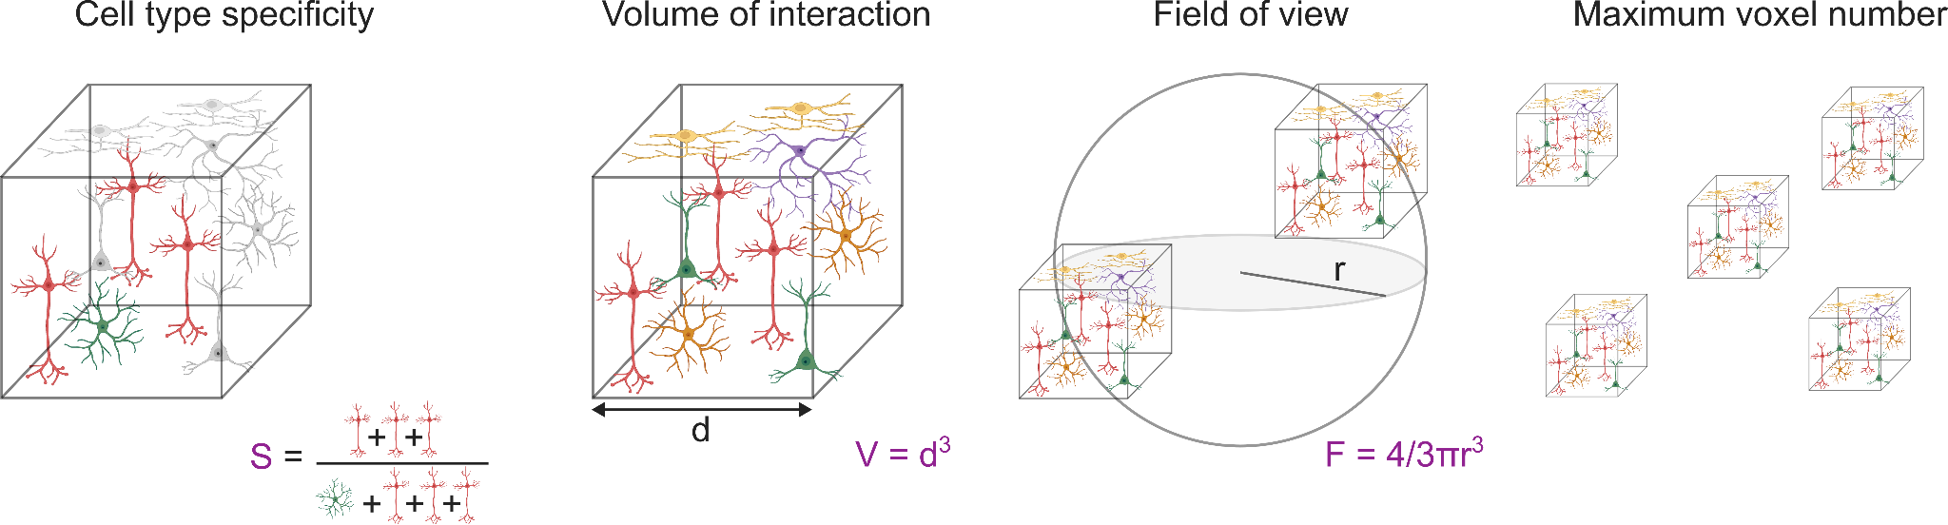
Figure 3. Shows four depictions from left to right to describe precision metrics. The first is describing cell type specificity, with neurons bounded by a cube with the equation S equals n/T. n is shown by a picture of the cell type specific neurons being recorded or written. T is given by a picture of the total number of neurons that contribute to the recorded/written signal. The second picture left to right, shows the volume of interaction, with neurons bounded by a cube and the equation V equals d-cubed with d being the length of one side of the cube presented. The third depicts field of view, with two cubes of neurons separated by a circular plane with the radius of the circle labelled and the equation F equals 4/3 x pi x radius-cubed the fourth image depicts maximum voxel number depicted by 5 cubes of neurons separated by an undefined distance.

Figure caption: Proposed precision metrics to enable circuit-level neural interfaces. While we believe that simultaneous advances in all these areas are important, we anticipate (and encourage) certain technology platforms to spike against particular performance metrics as well as certain conditions to require particular performance.

We have identified the following ‘precision metrics’ that should be simultaneously advanced towards the goal of circuit-level neurotechnologies (Figure 3):

- Cell type specificity (S)
To capture cell type specificity we define the unitless quantity$S=n/T$, where $n$ is the number of cell type specific neurons that contribute to the recorded/written signal and $T$ is the total number of neurons contributing to the recorded/written signal. For example, if the intended modulation target are GABAergic interneurons and $n=5$ are modulated in a particular volume, but 5 non-interneurons are also modulated, then $S=5/(5+5)=0.5$. We note that different cell types in different brain regions will have different chance $S$ values. For example, in the cerebral cortex pyramidal cells make up ~80% of all neurons. Therefore, with no specificity $S=0.8$, so a normalisation factor should be included that scales $S∈[1/N_{c},1]$ where $N_{c}$ is the number of cell types of interest. We note that cell type can be defined in a number of ways (functionally, morphologically, transcriptomically) and leave it up to teams to select their working definition.
- Volume of interaction (V)
A smaller volume of interaction enables distinct circuit elements to be individually addressed and to minimise off-target effects. The term ‘volume of interaction’ is intended to capture the functional volume that is directly recorded/written, rather than simply the integrated field.
- Field of view (F)
Field of view refers to the maximum addressable volume across the brain. We define it volumetrically to account for differences between e.g. axial and lateral fields of view. A larger field of view enables the simultaneous targeting of distinct brain regions e.g. cortex and basal ganglia.
- Maximum voxel number (N)
Increasing the maximum number of addressable targets enables multiple brain regions or micro-circuit elements to be targeted simultaneously, for example, to recruit plasticity mechanisms between disordered brain areas.

The first two elements refer to the ‘localisation’ of a neurotechnology, while the former two elements refer to the ‘scale’ of a neurotechnology (see Figure 4). We now combine these elements via the L2-norm to define a ‘precision metric’. This is intended to monitor order of magnitude improvements over the state-of-the-art and highlights how various technologies might spike against different precision elements:

$P=\sqrt{|(F/V_{cns}){Log}_{10}(N)|^{2}+|(S/S_{0}){Log}_{10}(V/V_{cns})|^{2}}$,

where $S_{0}$ is the cell type selectivity normalisation factor and $V_{cns}$= 1200 cm³ is the volume of the human central nervous system [48]. In Figure 4 we plot the localisation and scale for various neurotechnologies.

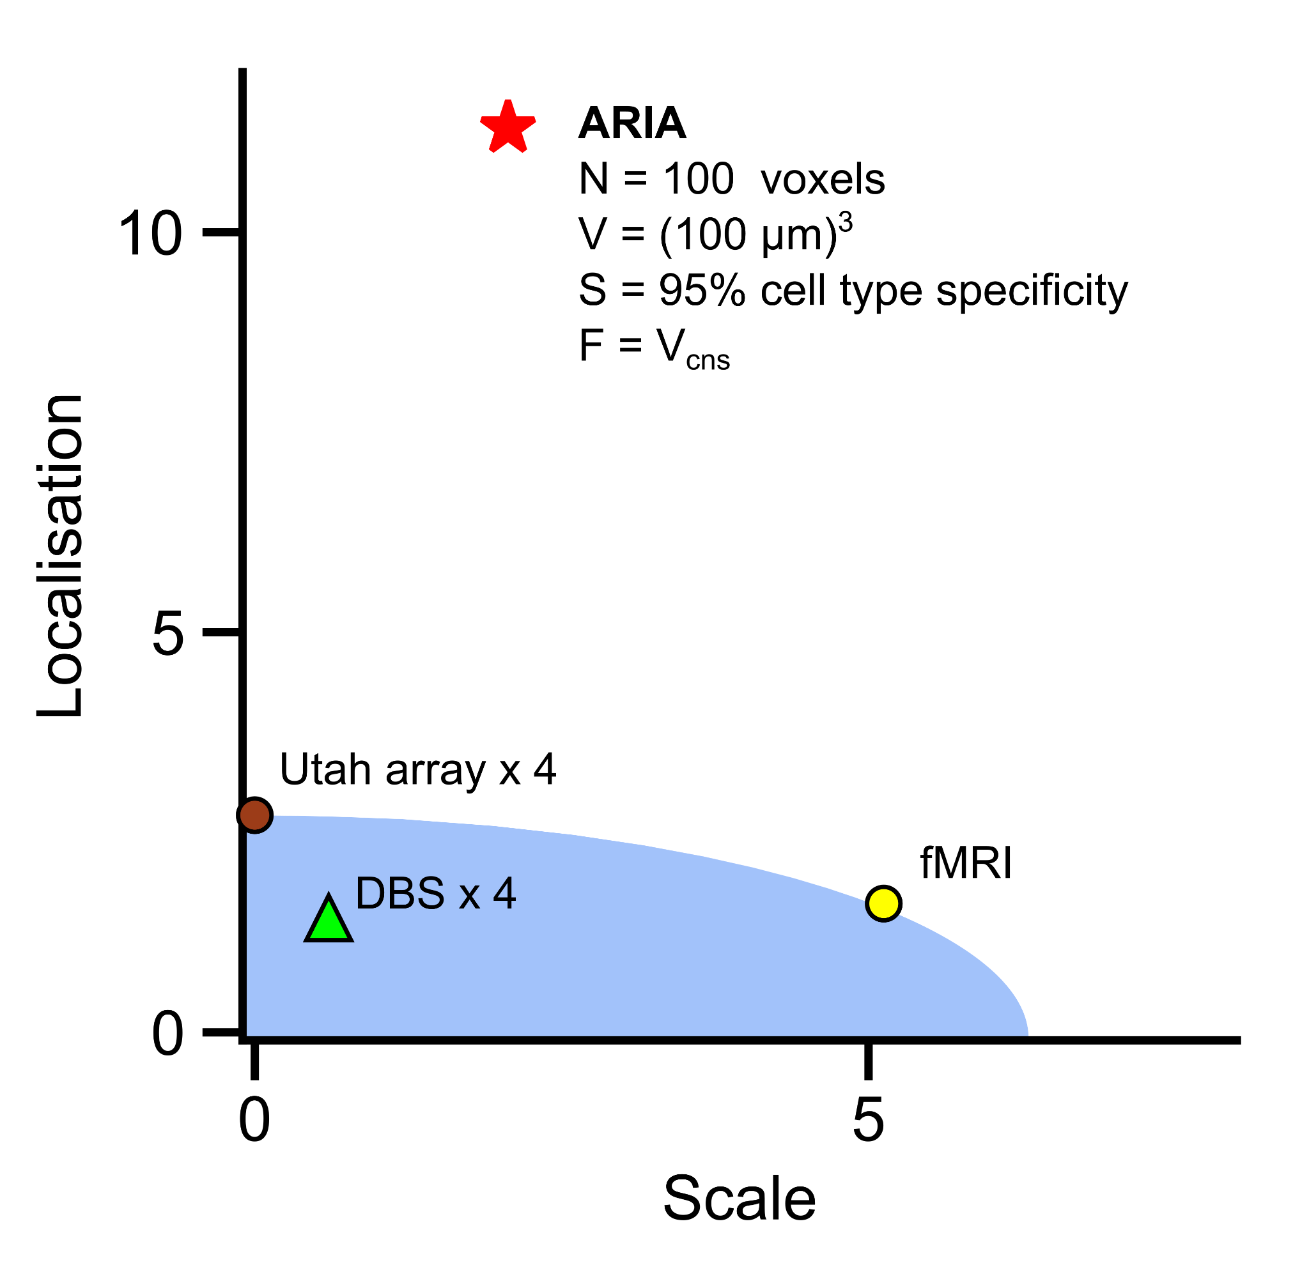
Figure 4. Shows a graph of the Pareto frontier of precision technologies. It shows localisation on the Y-axis and scale on the X-axis. Three current neurotechnologies are shown on the graph as data points and what an ARIA programme output could aim for: DBS is labelled with a green triangle, Utah arrays are labelled with a red circle, fMRI is labelled with a yellow circle. The three technologies sit within or on the limit of a blue boundary region between roughly 3 on the localisation axis and 5.5 on the scale axis. The ARIA target is given by a red star and sits above 10 on the localisation axis and roughly 2.5 on the scale axis. The text underneath the ARIA star reads N equals 100 voxels, V equals one hundred micron cubed, S equals ninety five percent cell type specificity, F equals V cns (volume of central nervous system).

Figure caption: Pareto frontier of precision neurotechnologies. The individual components of scale and localisation are plotted for three different state-of-the art technologies: fMRI [49], four implanted Utah arrays [50] and four implanted DBS leads [51]. A potential precision goal for this programme (red star) is also plotted.

