Exploring Options for Actively Cooling the Earth
Programme Thesis
v1.0
Mark Symes, Programme Director

CONTEXT
This document presents the core thesis underpinning a programme that is currently in development at ARIA. We share an early formulation and invite you to provide feedback to help us refine our thinking.

This is not a funding opportunity, but in most cases will lead to one – sign up here to learn about any funding opportunities derived or adapted from this programme formulation.

An ARIA programme seeks to unlock a scientific or technical capability that

- changes the perception of what’s possible or valuable
- has the potential to catalyse massive social and economic returns
- is unlikely to be achieved without ARIA’s intervention.

PROGRAMME THESIS, SIMPLY STATED
This programme thesis is derived from the ARIA opportunity space: Managing our climate and weather through responsible engineering

Climate change, caused by anthropogenic greenhouse gas emissions, could cause the global temperature to increase by several degrees by the end of the century, precipitating climate tipping points with serious consequences. The solution to this problem is to cease the burning of fossil fuels and to eliminate excess greenhouse gases from the atmosphere. However, lowering atmospheric greenhouse gas levels – even under the most aggressive scenarios – may not happen fast enough to prevent the onset of tipping points.

Such reasoning has led to proposals for methods to actively cool the Earth in order to buy time to decarbonise, and there has been considerable debate around the risks and benefits of these various methods. However, in the absence of significant physical (as opposed to simulated) data on the mechanisms behind how these approaches might work (and what their effects might be), there is no prospect of being able to make proper judgements on what are or are not feasible, scalable and controllable technologies for cooling the Earth.

Through short-duration, small-scale and geographically-confined field trials, this programme aims to answer fundamental questions as to the practicality, measurability and controllability of such technologies. In answering these questions, we plan to fund not only the field trials themselves, but also the necessary modelling, simulation, indoor experiments, observation and monitoring required to support the trials, as well as research into the legal, ethical, governance and geopolitical dimensions of the approaches under investigation. Our objective is that the information gathered by this programme will allow for more definitive assessments on whether one or more of the approaches examined may one day be used responsibly and ethically to delay or avert the onset of temperature-induced climate tipping points.

PROGRAMME THESIS, EXPLAINED
A detailed description of the programme thesis, presented for constructive feedback

Why this programme
Risk vs. risk
In light of the Intergovernmental Panel on Climate Change’s (IPCC) assessment that global warming in excess of 1.5 °C above pre-industrial levels is now likely (even if increased action allows the world to achieve net zero emissions by 2040) [1], and that “the pace and scale of what has been done so far, and current plans, are insufficient to tackle climate change” [2], there is increasing debate as to whether society must buy time to decarbonise by manipulating certain variables to reduce global temperatures on a short-to-medium term basis.

This comes against a background of concern around climate tipping points (abrupt alterations in the Earth’s climate system), which may lead to essentially irreversible disruptive changes on a regional or global scale if the global temperature exceeds certain thresholds for any length of time [3,4]. Examples of such tipping points include the melting of the Arctic winter sea ice (leading to accelerated warming via ice-albedo feedback [5]), dieback of the Amazon rainforest and consequent ecosystem loss, and collapse of the major land-based ice sheets, leading to significant global sea level rises.

The thresholds for many such tipping points remain far from clear, and it seems likely that a certain amount of continued global warming is already locked in, both on account of the amount of carbon dioxide already in the atmosphere [6,7] and due to the practical difficulties of rapid decarbonisation [8]. In this context, approaches such as stratospheric aerosol injection [9], marine cloud brightening [10], increasing the reflectivity of the Earth’s surface (e.g. by re-growing ice sheets), [11] and constructing space-based reflectors to shade the Earth from a proportion of incoming sunlight [12] have all been proposed as potential methods by which to cool the Earth and keep us from encountering future temperature-related tipping points whilst sufficient carbon dioxide is removed from the atmosphere to bring global temperatures down.

However, many poorly-constrained risks associated with the approaches above currently exist, especially regarding the scope and scale of their side-effects — which may affect different parts of the world unevenly [13]. Concerns also exist related to moral hazard [14], and the extent to which developing the capability to lower global temperatures without lowering atmospheric greenhouse gas levels (i.e. “treating the symptoms, but not the disease”) reduces the incentive to reach net zero and/or remove carbon dioxide from the atmosphere in a timely manner.

In many cases, the arguments for or against researching methods that may be used to reduce global temperatures boil down to a balance of risks [15]. Do the risks of unintended consequences and moral hazard associated with Earth-cooling technologies outweigh the risks of continued global warming without researching any intervention strategies? How should we weigh the risks associated with researching technologies for reducing global temperatures against the risk that the world discovers in 2040 or 2050 that efforts to achieve net zero and to remove carbon dioxide from the atmosphere have been insufficient to prevent very detrimental tipping points? In such a scenario, what might be the risks of hurried deployment of under-researched climate engineering technologies where we have little understanding of the consequences? And if these technologies were deployed, what might be the risks associated with termination shocks when we stopped using them [16]? Such questions have fuelled a debate that has been ongoing for years [17], but without firmer data on how the proposed technologies might work, their scalability, and what their effects might be, it is unlikely that the conversation will move forward.

Our discovery process has suggested to us that a key barrier to advancing our understanding of this field and being able to reach more definitive conclusions on particular approaches is a comparative dearth of real and relevant physical data from field trials [18-20]. Hence, we see a need for a programme that will conduct small, controlled, geographically-confined outdoor field trials on technologies that may one day scale to help reduce global temperatures. These trials are not designed as stepping stones to deployment, but to answer fundamental questions as to the practicality, measurability and controllability of the proposed approaches, and where further indoor trials are no longer able to provide these answers. To support the field trials, we plan to fund activities ranging from modelling and simulation, through to necessary indoor experiments, in-field observation and monitoring, and research on the legal, ethical, governance and geopolitical dimensions of the approaches under study.

The research conducted in this programme should allow us to provide critical and currently missing real-world data to scientists and society on what the options are for actively cooling the Earth, how such technologies might work, and what the consequences of their use might be, allowing better-informed assessments of their risks and benefits. Successful outcomes from this programme include ruling particular options out from further study as technically infeasible, ruling them out as infeasible due to risks that cannot be adequately constrained, or highlighting which approaches show promise and would benefit from further research and development.

Our approach
Our approach will be to develop a scientific framework to underpin strong predict → test → monitor → validate loops for a range of approaches (Figure 1). The “predict”, “monitor” and “societal aspects” nodes in Figure 1 have received some (although arguably insufficient) interest in recent years. However, research into how approaches for cooling the Earth might work in practice, how their effects would be demonstrated with statistical confidence, and how any resulting technology might be scaled effectively has received much less attention. Therefore, whilst further research across all of the areas shown in Figure 1 is vital, we see that the “test” and “validate” nodes are particularly underserved.

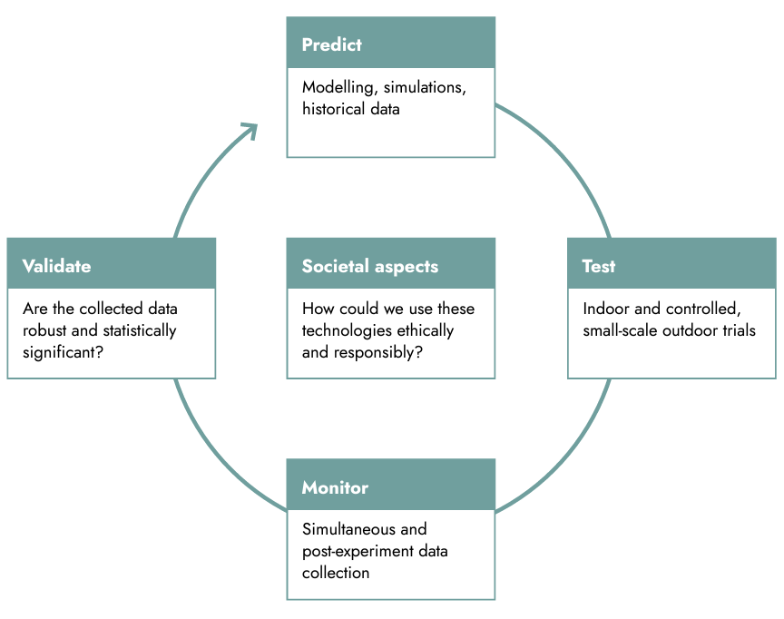
Figure 1: A technology research loop showing the “predict”, “test”, “monitor”, “validate” and “societal aspects” nodes.

Computer modelling and indoor testing of technologies are essential and necessary first steps in establishing the basic science behind how (or whether) a particular approach might work. However, modelling and indoor testing alone cannot provide all the data necessary to predict the effects of a given approach on the real world with a suitable level of confidence. Controlled field trials are therefore likely to be required to truly advance our understanding of the phenomena underlying potential approaches. Initial thoughts on how field trials in this programme could be conducted openly and responsibly are presented throughout this thesis for constructive feedback, with the aim that these form the basis for decisions on whether any given field trial could proceed and how the field trials could be conducted responsibly.

A suggested framework for field trials
There is the potential for unintended negative consequences in any field trial. Therefore, it will be important to define transparently and at the outset a set of principles that can guide the programme’s consideration of whether and how field trials can proceed. ARIA has incorporated lessons from previous projects where outdoor field trials have been cancelled before commencing [21,22] and those where field trials have gone ahead [23,11] in developing these principles, with the aim of supporting the development of best practices for safe and transparent field trials.

Our guiding principle for field trials is that these should be conducted on the smallest possible length and timescales required to validate with statistical confidence that the technologies under test can affect the parameters under investigation. These scales will be technology-specific; however, Appendix A posits what the upper bounds for the scale and duration of a field trial could be. In all cases, we expect initial outdoor trials to occur at much smaller scales than these upper bounds (for example, an appropriate scale for an initial outdoor cloud brightening experiment might be on the order of a few hundred metres).

The magnitude of the intended perturbation should be limited so that it is within the bounds of known and benign natural phenomena (or anthropogenic phenomena that are considered harmless), so that there is precedent for the size of the effect that will be produced. ARIA is also considering stipulating that the effects of any trial should be such that the effects either dissipate through natural mechanisms within hours, or else that there should be an obvious and reliable mechanism for switching off the effect at any time, on demand. A combination of considerations on size, duration and reversibility of field trials leads to the following suggested decision tree for assessing whether a particular field trial might be supported through this programme (Figure 2).
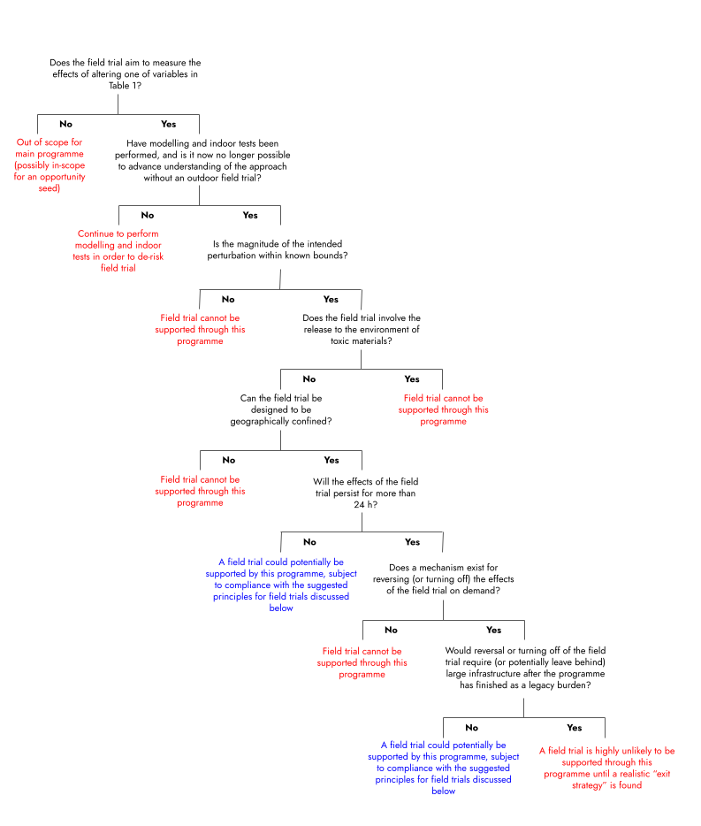
Figure 2: A suggested field trial technical consideration decision tree, to be used in conjunction with the principles for field trial oversight described in the main text.

The suggestion is that applicants proposing field trials would use this decision tree at application stage in order to see if their intended field trial could in theory be supported by this programme or not. This basic technical information would then feed into the following suggested principles for oversight of the eventual field trials, which are presented here for feedback:

- ARIA will not fund field trials where the activities proposed are prohibited by domestic or international law. Project teams will be required to show how their tests comply with all applicable laws.
- A risk assessment will be performed and the findings made publicly available before any trial. This will be conducted by experts who are independent of the team performing the trial, and will include relevant potential technological, environmental and socio-economic risks.
- Minimising risk by design. Field trials should be designed at the minimum viable scale required for the generation of robust data, and where the magnitude of any perturbation has a natural analogue or commonly accepted anthropogenic precedent (and therefore where the effect of the perturbation is within the range of known and benign phenomena). Such considerations are summarised in Figure 2.
- Transparency, public participation and consultation. Wherever possible, those conducting field trials will be required to notify and consult those who could be reasonably be considered as likely to be affected by the trials (noting that some trials will be so small and confined that no one beyond the experimenters themselves could reasonably be considered as at all likely to be affected). To facilitate informed decision making, detailed plans for the field trials, and the key decisions taken in developing these plans, will be consulted upon as transparently as possible well in advance of any trial (including what the trials involve, why the trials are necessary, who is conducting the trials, and who might be impacted by the trials). The results of any trial will also be made publicly available.
- Independent impact assessment. Post-trial, the environmental and any socio-economic impacts will be assessed by experts who are independent of the team performing the trial, and the results of this assessment will be made publicly available.
- Limited scope. Activities in this programme will be limited to research scale – ARIA will not fund deployment, or any demonstration beyond the approved trial.
- Structured oversight. ARIA’s leadership will be responsible for programme approval and governance oversight, leveraging input from independent experts. ARIA has also established a Committee of the Board for ethical and social responsibility, which will have visibility across all ARIA programmes.

A key goal of the programme will be to establish a culture of complete openness for field trials in terms of what activities are undertaken and their outcomes, similar to that which the International Civil Aviation Organization champions for the sharing of best practices in the aviation industry [24]. The principles above are designed to embed this mindset from the beginning of the R&D pathway for the technologies supported by a future programme in this space.

What we expect to fund
Funding across silos
We anticipate supporting research into approaches for reducing global temperatures across the full range of science and engineering disciplines. We also expect to support projects across the social sciences that are of direct relevance to those approaches (including, but by no means limited to, consideration of public perception, potential legal, ethical, regulatory and governance frameworks, ethics, community engagement, and the economic impact of those approaches). ARIA is aware of previous and ongoing initiatives that have considered some of the ethical and societal issues around governance, stakeholder engagement and perceptions related to approaches for actively cooling the Earth over the last few years (see, for example: [25-28]). It will be incumbent on proposers to demonstrate how any proposed research avoids duplication of effort with previous studies, be this in regards to technological or social research.

ARIA aims to provide as much flexibility as possible in terms of how the social sciences are represented in this programme. For example, ARIA may fund social scientists to work specifically on certain technology research teams. In addition, ARIA may also fund a dedicated social science strand that works across the full range of technological approaches under investigation, in a manner that complements the efforts of social scientists that are embedded in specific research teams.

ARIA’s ultimate aim is to integrate aspects of all the nodes in Figure 1 (including relevant societal aspects) into each project, but we appreciate that different projects will have different requirements and that such integration may take time. Therefore, ARIA is open to receiving proposals for (and indeed funding) projects that focus solely on one node of Figure 1 in the first instance, with a view to encouraging greater cohesion between the different nodes as projects progress (see also “How we expect to fund” below). Encouraging cohesion might also include suggesting that various teams combine their efforts at full proposal submission or award negotiation stage. If ARIA identifies areas that are especially poorly represented in submissions to the initial call, then we may issue a further call for relevant expertise in those areas.

What will projects need to demonstrate?
The overarching goal of this programme is to answer fundamental questions on the practicality, measurability and controllability of technologies that might one day be used to actively cool the Earth. Projects will therefore need to demonstrate how they align with this goal.
A very simplified estimate of the equilibrium temperature at the Earth’s surface (T_{surf}) is provided by the equation below [29]:

$T_{surf} =\sqrt[4]{\frac{S(1-α)}{2σ(2-ε)}}$

Where S is the solar constant (the power per unit area impinging on the Earth from solar irradiation), ɑ is the planetary albedo (a measure of how much short-wave radiation is reflected from the Earth without being absorbed), 𝜎 is the Stefan-Boltzmann constant, and 𝜀 is the effective emissivity of the atmosphere (𝜎 and 𝜀 together give a measure of how much long-wave radiation is emitted by the Earth back out to space). Therefore, in order to be in-scope for this programme, projects will need to demonstrate how the approaches that they are researching have the potential to alter T_{surf} (at any scale) by affecting at least one of the variables ɑ, ε or S (see Table 1) in a manner that is statistically distinguishable from the background (or to demonstrate the relevance of the proposed activities to such research). Applicants will need to consider testability and statistical significance in their proposals (for example, can any parallels or lessons be drawn from some of the ways in which statistical methods have been employed to evaluate field trials of cloud seeding [30-32]?).

Table 1: Variables for study in this programme. The examples of activities that could address these variables are not exhaustive, and neither should they be construed as use cases that ARIA considers to be more or less valuable than any others that can be imagined.

Variable | Examples of activities that could address this variable
Planetary albedo (ɑ) | Marine cloud brightening [10]; ice sheet thickening [33]
Effective solar constant (S) | Space-based reflectors [12]
Effective emissivity of the atmosphere (𝜀) | Cirrus cloud thinning [34,35]

Programme differentiation
To date, there have been very few actual (or even attempted) field trials of technologies whose ultimate goal would be to reduce global temperatures on a short-to-medium term basis, and we are not aware of any other programmes that have funded field trials of multiple different approaches in a coordinated way. Indeed, to date, all field trials that have been attempted or conducted in this space have been undertaken as individual stand-alone projects. This means that these projects have therefore also struggled to cover all of the nodes represented in Figure 1 comprehensively.

This programme has a strong emphasis on statistical significance and on understanding the physical principles that underlie the effects that the various approaches may produce. In this context, even if the only outcome of the programme is to prove that all the approaches that are investigated are either infeasible at scale or produce effects that are indistinguishable from natural background processes, then we will consider this a success. Such an outcome would directly support our objective to allow better-informed assessments as to whether any of the approaches examined may one day be used responsibly and ethically to reduce global temperatures on a short-to-medium term basis. This technology and outcome agnosticism strongly differentiates this programme.

Programme scope
Table 2 gives a breakdown of areas that we expect to be out of scope for this programme, along with the reasoning we have taken in coming to these decisions. Approaches that are not explicitly listed as out of scope will be considered (provided that their specific intent relates to the controlled perturbation of one of the variables given in Table 1). Opportunity seed funding will be available to support individuals or teams pursuing ambitious research that is out of scope for the programme, but which falls within the scope of the wider opportunity space Managing our climate and weather through responsible engineering.

Table 2: Out of scope areas for this programme

Topic or activity | Reasoning and comments
Removal, sequestration and/or utilisation of carbon dioxide | Multiple other public and private funders are already funding carbon dioxide removal and utilisation
General weather/climate simulation or monitoring activities that do not provide insights into the effects of altering one of the variables in Table 1 | Only simulation or monitoring activities that could be relevant to the temperature-reducing approaches being researched in this programme will be in scope. This programme is distinct from the work of the Natural Environment Research Council and their upcoming Research programme to model the impact of solar radiation management [36], and has been developed independently. ARIA will continue to engage with NERC as development of both programmes progresses.
Field trials where analysis via Figure 2 indicates that such a field trial cannot be supported by this programme | This programme aims to perform field trials that can be geographically confined, are short in duration (or can be switched off on short timescales) and that are readily reversible through natural processes. Field trials that Figure 2 indicates cannot be supported will not be funded through this programme
Large-scale trials of climate engineering technologies continuously or over extended durations | This programme will only fund activities at research and small field trial scale

How we expect to fund
Project and programme structure
In general, ARIA is open to funding individuals, universities, research institutions, small, medium and large companies, charities and public sector research organisations to undertake projects, and we will fund a portfolio of different approaches. We will fund early-stage and conceptual ideas through to more developed technologies and capabilities. Applications may therefore be initially highly speculative and may constitute one or more individuals or teams working together at the point of application. As projects develop, we would expect additional partners to join project teams to add their expertise; in some cases, ARIA may make the continuation of funding contingent on adding additional expertise to the project team. We also expect that some projects may fail to meet their agreed assessment criteria, which could result in a managed phase-down of funding or a pivot in a new direction. Project teams will be able to bid for additional funding during the course of ongoing projects in order to bring in new members, explore new avenues, or undertake scale up or other activities which were not anticipated at application stage, but for which a strong case can be made. A schematic illustrating how this could work in practice is shown in Figure 3.

We anticipate that there will be a single call for proposals, with applicants able to request funding for durations ranging from a few weeks to five years. We aim to be as flexible as possible with our funding and to make additional funds available to successful projects. Projects opting to specify durations towards the longer end of the five-year maximum and requesting larger sums at initial application stage will be required to supply stronger justification for their requests. Conversely, more speculative projects may wish to request a shorter duration at application stage, with the possibility that ARIA will follow up with more substantial funding in the event that the project meets its objectives. The aim is to allow projects to “fail fast”, to reward success, and to help ARIA manage risk across the portfolio of funded projects. In cases where project teams ask for large awards of long duration at initial application stage, but ARIA considers the overall project to be too high risk, ARIA reserves the right to fund only the first stages of the proposed scheme of work, with the possibility of releasing further funding later on if progress de-risks the later stages of the project sufficiently.

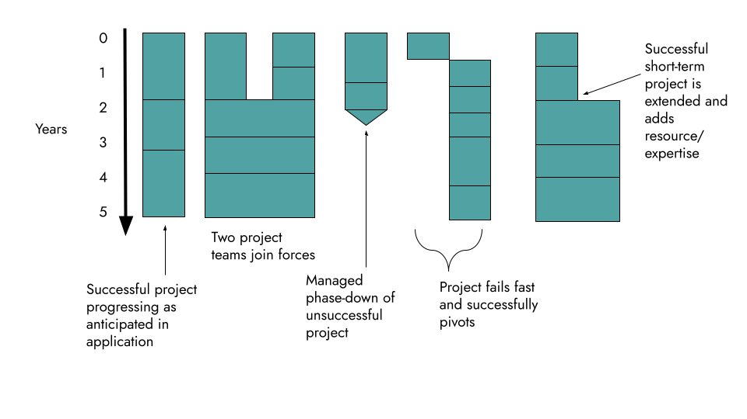
Figure 3: Illustration of the responsive funding structure. Horizontal bars indicate project review points.

Initial guidance on application procedure and assessment
We expect that there will be a single application process consisting of two stages.

Stage One will consist of the submission of a short “concept paper” (three sides of A4 maximum, including all figures and references) that describes the proposed research. Applicants will also be asked to complete a separate outline estimated budget at Stage One, and answer some basic questions on expected project length, team members and so forth.

The window for applications to Stage One is likely to be only around four weeks. To stay informed and to receive timely notifications about the opening of the call, applicants are encouraged to sign up for updates. You can sign up for updates here.

Following review of concept papers, applicants will either be encouraged or discouraged from submitting a full proposal (Stage Two). Based on this feedback, applicants can then decide whether or not to submit a full proposal. ARIA may suggest that certain proposing teams combine before submitting to Stage Two if this would produce a stronger proposal. Should applicants miss the deadline for submission of concept papers, they can still submit a full proposal at Stage Two.

At Stage One, applicants will be asked to provide the following information (additional administrative information will also be required relating to budgets, timelines etc.).

- Programme alignment. Applicants must propose research related to approaches for cooling the Earth as per the aims and scope described above.
- Description of research and methodology. A brief summary of the proposed research project, and how it supports the objectives of the chosen pathway. A description of the approach or methodology that will be employed to address the research objectives, including:
  - A description of the approach, capability proposed and (where relevant) the technology proposed.
  - Any data (this may include scientific rationale) to support your proposed concept – supporting data, journal articles, blogs, code or other materials may be referenced or linked to in the submission if they directly support your paper.
  - Identification of the technical and non-technical challenges or obstacles that must be overcome to achieve the research goals. This includes potential risks and mitigation strategies. Proposers suggesting field trials will be required to indicate briefly how they plan to comply with the principles for field trials outlined above and/or flag areas in which they anticipate that they will require support or additional resources in order to comply.
- An overview of the proposed activity of work, any key metrics and milestones and any dependencies and assumptions.
- An overview of the proposed project team including information about the expertise of the research team, relevant experience, skills, and capabilities. Stage One applications do not need to cover all the nodes shown in Figure 1. However, if proposers are able to identify additional expertise that is likely to be required as the project progresses it would be useful to flag that at Stage One, together with the strategy and timeline for introducing this expertise into the project. Strong proposals will be able to articulate clearly why the team has the expertise to undertake the proposed project as-is, or what additional expertise might be required and how this would be procured.

Concept papers are designed to make the solicitation process as efficient as possible for applicants. By soliciting short concept papers, ARIA reviewers are able to gauge the feasibility and relevance of the proposed project and give an initial indication of whether we think a full proposal would be competitive.

Stage Two is the submission of fully-detailed proposals including:

- Project & technical information to help us gain a detailed understanding of your proposal. At Stage Two, proposers will be required to suggest their own project-specific success criteria as part of their overall hypotheses, as well as a timeline for delivering these.
- Information about the team to help us learn more about who will be doing the research, their expertise, and why you/the team are motivated to solve the problem.
- Administrative questions to help ensure we are responsibly funding R&D. These questions relate to budgets, IP, potential conflicts of interest, etc.

Both concept papers and full proposals will be subjected to rigorous expert review. Find more information on ARIA’s review and selection process here.

ARIA will then engage in negotiations with shortlisted applicants and will work together with those teams to develop their suggested success criteria into a rigorous set of staged performance metrics with which to gauge project progress. ARIA expects that each funded project will therefore have its own unique set of testable hypotheses, with a number of associated predefined and quantifiable key performance targets. ARIA may make use of third-party independent validation and verification at project review points in order to ensure rigour in the assessment of project performance. Timelines for field trials and the steps that would need to be taken before these could take place will be discussed on a case-by-case basis during this negotiation phase.

What we are still trying to figure out

A number of open questions remain in shaping this programme, a few which include:

- Can we further refine the programme’s technical objectives to ensure that the learnings from this research provide critical (as opposed to marginal) advances in evaluating viability of these approaches?

- Can we develop a robust risk, cost-to-benefit, and/or other assessment framework that captures the societal benefits and costs involved in this research?

- What facilities or tools would be useful to enable more productive and trusted research in this field??

- ARIA is considering how to encourage collaboration, openness and sharing of best practice among and beyond the project teams that are funded through this programme. This could include funded teams providing advisory support to other funded projects within the programme. Comments on this proposed model are welcome, as are suggestions for other ways in which programme cohesion,sharing of best practices and maintaining trust could be facilitated.

SOURCES
References cited in this document.

[1] “Mitigation Pathways Compatible with 1.5°C in the Context of Sustainable Development,” Cambridge University Press, 2022, p. 93174. doi: https://doi.org/10.1017/9781009157940.004.

[2] IPCC, “Urgent Climate Action Can Secure a Liveable Future for All — IPCC,” IPCC, Mar. 20, 2023. https://www.ipcc.ch/2023/03/20/press-release-ar6-synthesis-report.

[3] D. I. Armstrong McKay et al., “Exceeding 1.5°C global warming could trigger multiple climate tipping points,” Science, vol. 377, no. 6611, Sep. 2022, doi: https://doi.org/10.1126/science.abn7950.

[4] P. D. L. Ritchie, J. J. Clarke, P. M. Cox, and C. Huntingford, “Overshooting tipping point thresholds in a changing climate,” Nature, vol. 592, no. 7855, pp. 517–523, Apr. 2021, doi: https://doi.org/10.1038/s41586-021-03263-2 .

[5] H. Kashiwase, K. I. Ohshima, S. Nihashi, and H. Eicken, “Evidence for ice-ocean albedo feedback in the Arctic Ocean shifting to a seasonal ice zone,” Scientific Reports, vol. 7, no. 1, Aug. 2017, doi: https://doi.org/10.1038/s41598-017-08467-z.

[6] K. L. Ricke and K. Caldeira, “Maximum warming occurs about one decade after a carbon dioxide emission,” Environmental Research Letters, vol. 9, no. 12, p. 124002, Dec. 2014, doi: https://doi.org/10.1088/1748-9326/9/12/124002.

[7] K. Zickfeld and T. Herrington, “The time lag between a carbon dioxide emission and maximum warming increases with the size of the emission,” Environmental Research Letters, vol. 10, no. 3, p. 031001, Mar. 2015, doi: https://doi.org/10.1088/1748-9326/10/3/031001.

[8] J. F. Abrams et al., “Committed Global Warming Risks Triggering Multiple Climate Tipping Points,” Earth’s Future, vol. 11, no. 11, Nov. 2023, doi: https://doi.org/10.1029/2022ef003250.

[9] E. Brody et al., “Kicking the Can Down the Road: Understanding the Effects of Delaying the Deployment of Stratospheric Aerosol Injection,” arXiv (Cornell University), Feb. 2024, doi: https://doi.org/10.48550/arxiv.2402.11992.

[10] H. Hirasawa, D. Hingmire, H. A. Singh, P. J. Rasch, and P. Mitra, “Effect of Regional Marine Cloud Brightening Interventions on Climate Tipping Elements,” Geophysical Research Letters, vol. 50, no. 20, Oct. 2023, doi: https://doi.org/10.1029/2023gl104314.

[11] “HOME,” Real Ice. https://www.realice.eco/

[12] I. Szapudi, “Solar radiation management with a tethered sun shield,” Proceedings of the National Academy of Sciences of the United States of America, vol. 120, no. 32, p. e2307434120, Aug. 2023, doi: https://doi.org/10.1073/pnas.2307434120.

[13] K. L. Ricke, M. G. Morgan, and M. R. Allen, “Regional climate response to solar-radiation management,” Nature Geoscience, vol. 3, no. 8, pp. 537–541, Jul. 2010, doi: https://doi.org/10.1038/ngeo915.

[14] D. McLaren, “Mitigation deterrence and the ‘moral hazard’ of solar radiation management,” Earth’s Future, vol. 4, no. 12, pp. 596–602, Dec. 2016, doi: https://doi.org/10.1002/2016ef000445.

[15] T. Felgenhauer, M. Brune, J. Wiener, and J. Xu, “Solar Radiation Modification: A Risk-Risk Analysis Carnegie Climate Governance Initiative An initiative of,” 2022. Available: https://www.c2g2.net/wp-content/uploads/202203-C2G-RR-Full.pdf.

[16] A. Parker and P. J. Irvine, “The Risk of Termination Shock From Solar Geoengineering,” Earth’s Future, vol. 6, no. 3, pp. 456–467, Mar. 2018, doi: https://doi.org/10.1002/2017ef000735.

[17] “Geoengineering the climate: science, governance and uncertainty,” The Royal Society, royalsociety.org, Sep. 2009. https://royalsociety.org/-/media/policy/publications/2009/8693.pdf

[18] D. W. Keith, E. Parson, and M. G. Morgan, “Research on global sun block needed now,” Nature, vol. 463, no. 7280, pp. 426–427, Jan. 2010, doi: https://doi.org/10.1038/463426a.

[19] D. W. Keith, R. Duren, and D. G. MacMartin, “Field experiments on solar geoengineering: report of a workshop exploring a representative research portfolio,” Philosophical Transactions of the Royal Society A: Mathematical, Physical and Engineering Sciences, vol. 372, no. 2031, p. 20140175, Dec. 2014, doi: https://doi.org/10.1098/rsta.2014.0175.

[20] G. Feingold et al., “Physical science research needed to evaluate the viability and risks of marine cloud brightening,” Science Advances, vol. 10, no. 12, Mar. 2024, doi: https://doi.org/10.1126/sciadv.adi8594.

[21] “The SPICE Project | SPICE,” http://www.spice.ac.uk.

[22] “Keutsch Group at Harvard - SCoPEx,” https://www.keutschgroup.com/scopex.

[23] “What is marine cloud brightening?,” Great Barrier Reef Foundation. https://www.barrierreef.org/news/explainers/what-is-cloud-brightening.

[24] ICAO, “Home,” Icao.int, 2019. https://www.icao.int/Pages/default.aspx.

[25] “European Transdisciplinary Assessment of Climate Engineering (EuTRACE) | Research Institute for Sustainability,” https://www.rifs-potsdam.de/en/research/eutrace (accessed Apr. 18, 2024).

[26] “C2G | Carnegie Climate Governance Initiative,” C2G. https://www.c2g2.net/solar-radiation-modification.

[27] “CO-CREATE,” EIEE - European Institute on Economics and the Environment. https://www.eiee.org/project/co-create accessed Apr. 18, 2024).

[28] N. Zuniga, “Degrees launches world’s first research fund for SRM social science in the Global South,” The DEGREES Initiative, Oct. 25, 2023. https://www.degrees.ngo/degrees-launches-worlds-first-research-fund-for-srm-social-science-in-the-global-south (accessed Apr. 18, 2024).

[29] J. A. Coakley Jr. and P. Yang, Atmospheric Radiation: A Primer with Illustrative Solutions. Wiley, 2014, p. Chapter 6, 185-201. Available: https://www.wiley.com/en-gb/Atmospheric+Radiation:+A+Primer+with+Illustrative+Solutions-p-9783527410989.

[30] W. L. Woodley and D. Rosenfeld, “The Development and Testing of a New Method to Evaluate the Operational Cloud-Seeding Programs in Texas,” vol. 43, no. 2, pp. 249–263, Feb. 2004, doi: https://doi.org/10.1175/1520-0450(2004)043%3C0249:tdatoa%3E2.0.co;2.

[31] D. Breed, R. Rasmussen, C. Weeks, B. Boe, and T. Deshler, “Evaluating Winter Orographic Cloud Seeding: Design of the Wyoming Weather Modification Pilot Project (WWMPP),” Journal of Applied Meteorology and Climatology, vol. 53, no. 2, pp. 282–299, Feb. 2014, doi: https://doi.org/10.1175/jamc-d-13-0128.1.

[32] X. Wu et al., “Advances in the Evaluation of Cloud Seeding: Statistical Evidence for the Enhancement of Precipitation,” Earth and Space Science, vol. 5, no. 9, pp. 425–439, Sep. 2018, doi: https://doi.org/10.1029/2018ea000424.

[33] R. Minunno, N. Andersson, and G. M. Morrison, “A systematic literature review considering the implementation of planetary geoengineering techniques for the mitigation of sea-level rise,” Earth-Science Reviews, vol. 241, p. 104431, Jun. 2023, doi: https://doi.org/10.1016/j.earscirev.2023.104431.

[34] D. L. Mitchell and W. Finnegan, “Modification of cirrus clouds to reduce global warming,” Environmental Research Letters, vol. 4, no. 4, p. 045102, Oct. 2009, doi: https://doi.org/10.1088/1748-9326/4/4/045102.

[35] C. Tully, D. Neubauer, D. Villanueva, and U. Lohmann, “Does prognostic seeding along flight tracks produce the desired effects of cirrus cloud thinning?,” Atmospheric Chemistry and Physics, vol. 23, no. 13, pp. 7673–7698, Jul. 2023, doi: https://doi.org/10.5194/acp-23-7673-2023.

[36] “Research programme to model impact of solar radiation management,” www.ukri.org, Feb. 28, 2024. https://www.ukri.org/news/research-programme-to-model-impact-of-solar-radiation-management (accessed Apr. 25, 2024).

[37] G. W. Platzman, “The Rossby wave,” The Quarterly Journal of the Royal Meteorological Society , vol. 94, no. 401, pp. 225–248, Jul. 1968, doi: https://doi.org/10.1002/qj.49709440102.

[38] D. R. Durran and M. Gingrich, “Atmospheric Predictability: Why Butterflies Are Not of Practical Importance,” Journal of the Atmospheric Sciences, vol. 71, no. 7, pp. 2476–2488, Jun. 2014, doi: https://doi.org/10.1175/jas-d-14-0007.1.

[39] P. A. Durkee et al., “Composite Ship Track Characteristics,” Journal Of The Atmospheric Sciences, vol. 57, no. 16, pp. 2542–2553, Aug. 2000, doi: https://doi.org/10.1175/1520-0469(2000)057%3C2542:cstc%3E2.0.co;2.

[40] P. Manshausen, D. Watson-Parris, M. W. Christensen, J.-P. Jalkanen, and P. Stier, “Invisible ship tracks show large cloud sensitivity to aerosol,” Nature, vol. 610, no. 7930, pp. 101–106, Oct. 2022, doi: https://doi.org/10.1038/s41586-022-05122-0.

[41] D. Watson-Parris, M. W. Christensen, A. Laurenson, D. Clewley, E. Gryspeerdt, and P. Stier, “Shipping regulations lead to large reduction in cloud perturbations,” Proceedings of the National Academy of Sciences of the United States of America, vol. 119, no. 41, Oct. 2022, doi: https://doi.
org/10.1073/pnas.2206885119.

ENGAGE
Our next step is to launch a funding opportunity derived or adapted from this programme formulation. Click here to register your interest, sign up for updates or to provide feedback that can help improve this programme thesis.

APPENDIX A: Initial analysis on field trial scale
Rossby waves [37] caused by the Earth's rotation define characteristic length scales for weather systems in the UK that are on the order of 1000 km. Work examining the impact that perturbations in weather models have on the predictability of atmospheric conditions suggests that very large perturbations (by up to 100%) can be made on a length scale of 10 km without any significant effect on the behaviour of the overall system (at 1000 km scale) [38]. Therefore, a maximum field trial grid parameter on the order of 10 km should be small enough that any perturbation caused in that space for short periods (e.g. 24 hours or less) will subsequently be dwarfed by natural chaotic processes operating at larger scales once the trial had ended. However, proposers will be required to start with field trials smaller than this (especially for initial trials) in order to demonstrate safety and controllability. Likewise, ARIA strongly prefers field trials in areas remote from population centres. Such scales place these field trials and their effects in the range of “microscale meteorology”, as distinct from both the larger weather systems that we are familiar with from weather forecasts and the climate at large (see Figure 4).

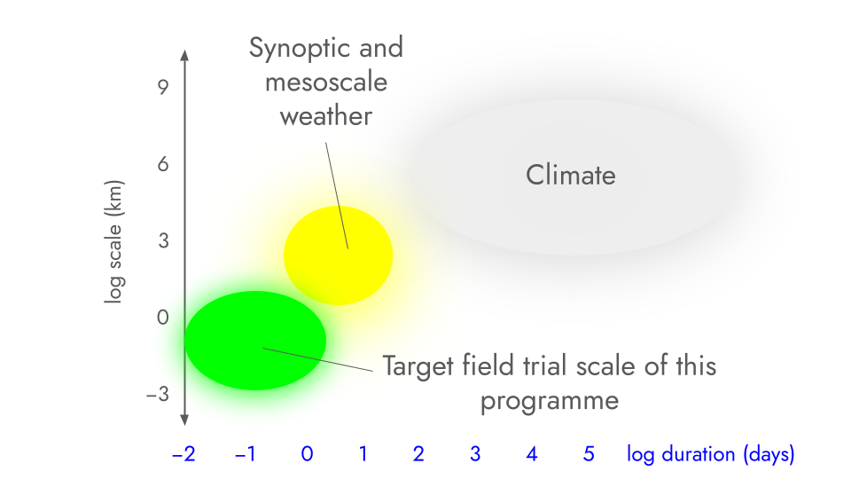

Figure 4: Context on the suggested scale and duration of field trials that we plan to target in this programme.

These suggested length and timescale upper bounds are commensurate with (or indeed smaller than) those previously employed in anthropogenic climate perturbation experiments. Two examples are provided. Firstly, the marine cloud brightening project operating on the Great Barrier Reef [23] generates a plume behind the vessel that can grow in extent to 10-20 km, with effects that dissipate within hours. Secondly, as an example of an “unintentional” climate perturbation experiment, the “average” ship track (clouds that form after ships pass through an area due to nucleation of water droplets on emissions released from the ships’ funnels) is on the order of 10 km wide and anything from a few km to several hundred km long [39]. Lifetimes for such artificially-generated clouds are generally a few hours, with formation starting around half an hour after emission of the exhaust [39]. The number of droplets in the track (corresponding to a peak brightness of the cloud) tends to peak roughly 3-5 hours after emission, with the track then fading such that the droplet count is indistinguishable from the background within 20 hours or so [40]. When the International Maritime Organization introduced tighter emissions limits for ships in an area off the coast of California in 2010, ships were obliged to navigate further from the coast. This in turn led to a dramatic shift (sustained over the timescale of years) in the location of ship tracks over an area of around 60,000 square kilometres [41].

